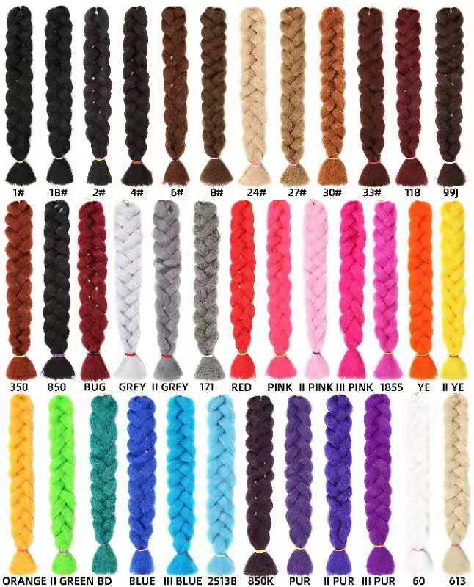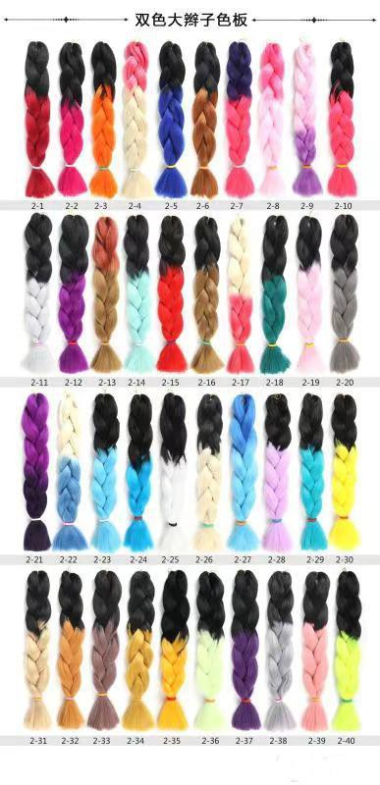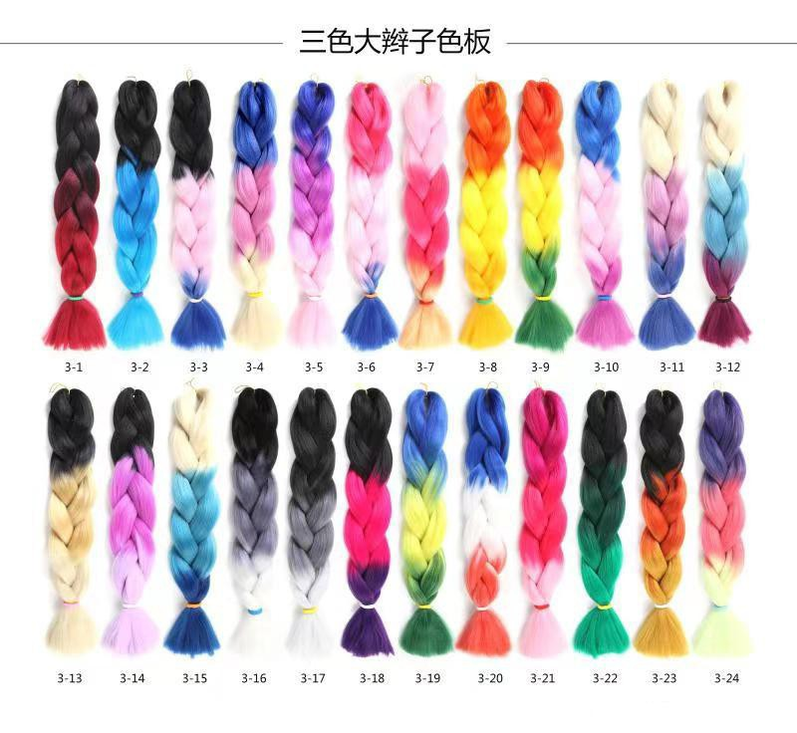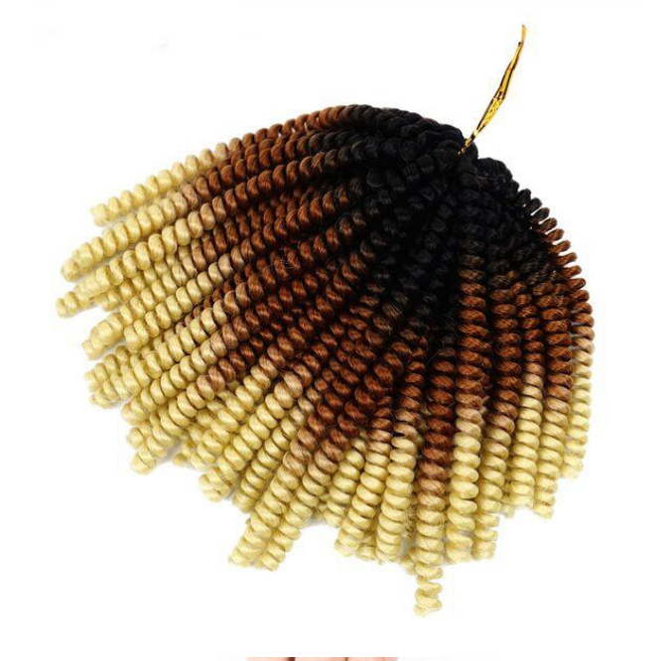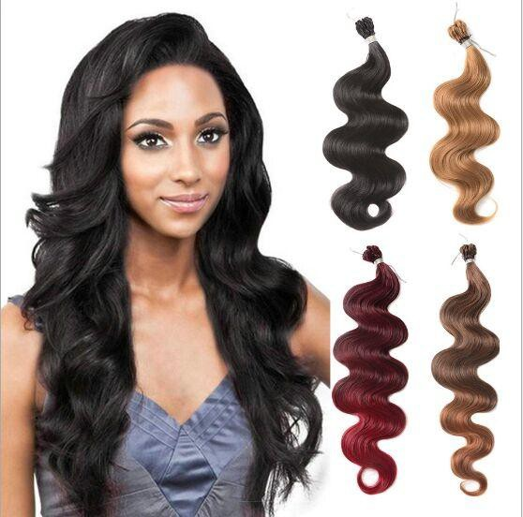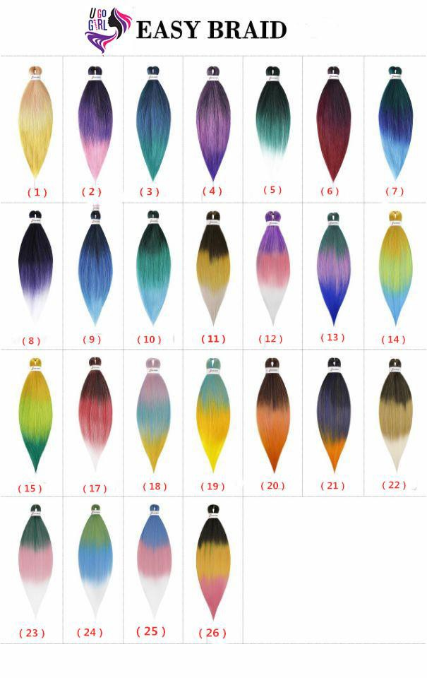BLACK BOX DISTRIBUTION INC
3402 Kettering Ct,San Mateo, CA 94403 US SAM@BOBSA.ORG 650-863-3491

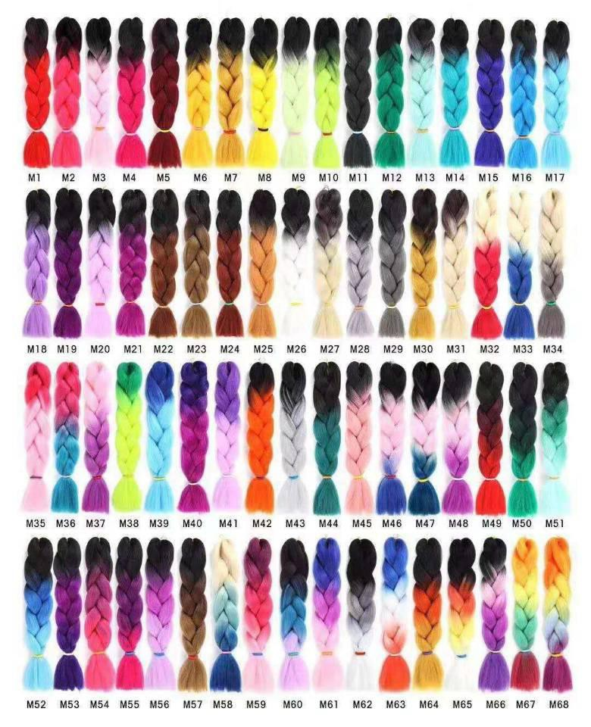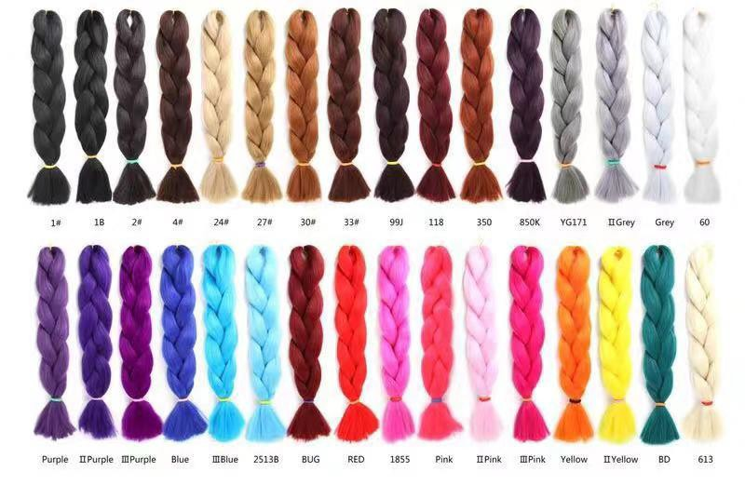Quotation of The Items on Inventory List

No. | Item Photo | Color Options | Item | Specs | Color | Unit Price
1 | 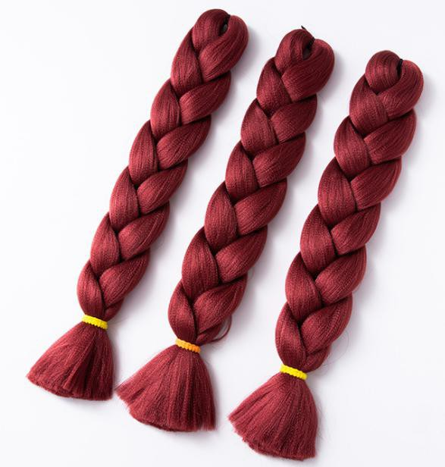 |  | Kanekalon Jumbo braids | 24 inches  100g/Pack | #1B (One-color style) | $0.65/pcs
2 |  |  |  |  | #M6 (Two-color style) | $1.03/pcs
3 |  |  |  |  | #M59 (Three-color style) | $1.21/pcs
4 |  |  |  |  | #M67 (Four-color style) | $1.35/pcs
5 | 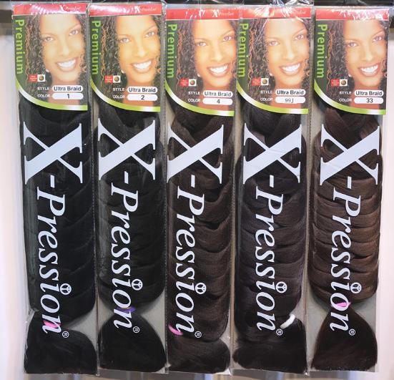 |  | Kanekalon Xpression braids | 82 inches  165g/pack | #2 (One-color style) | $1.09/pcs
6 |  |  |  |  | #2-1 (Two-color style) | $1.61/pcs
7 |  |  |  |  | #3-1 (Three-color style) | $1.99/pcs
8 | 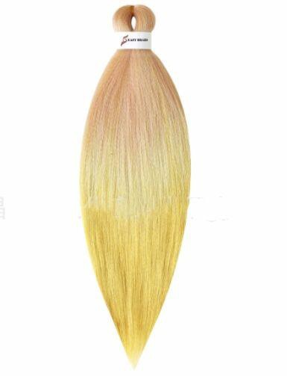 | 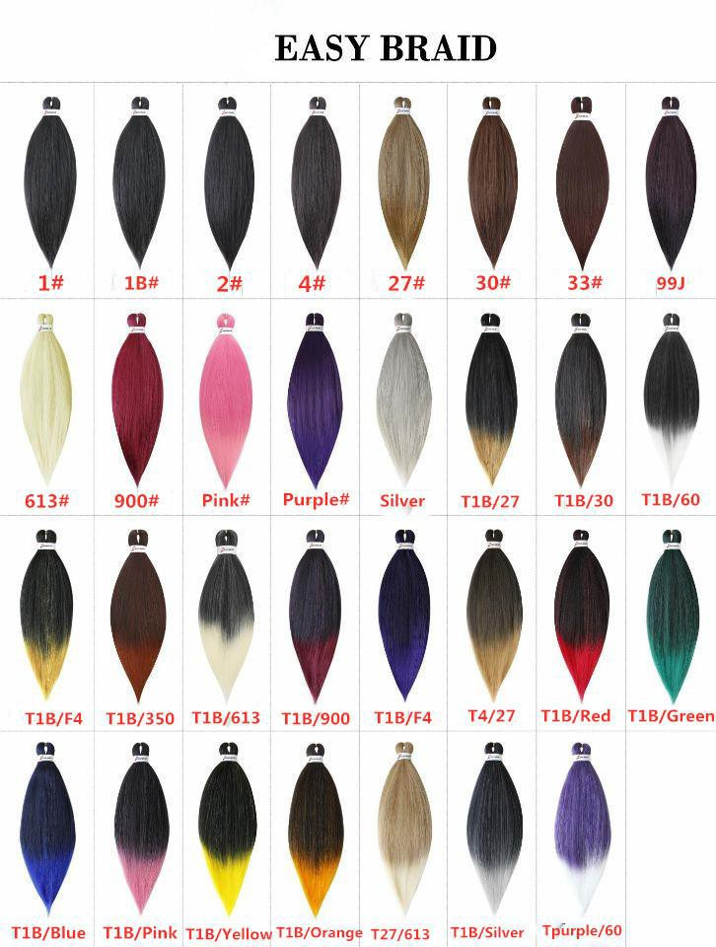 | Easy braid（EZ）  Pre-stretched braids | 20", 75g/pc | #1 | $1.04
9 |  |  |  |  | #27 | $1.04
10 |  |  | Easy braid（EZ）  Pre-stretched braids | 26", 95g/pc | #30 | $1.04
11 |  |  |  |  | #T1B/Bug | $1.04
12 |  | 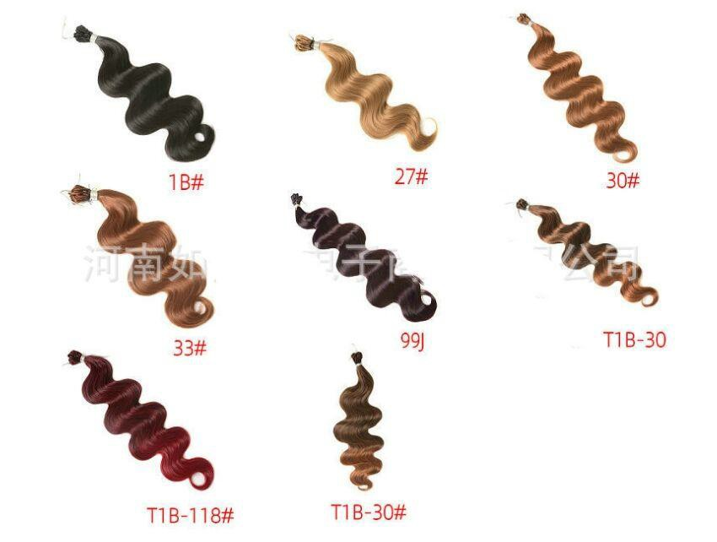 | Body wave crochet braids | 18”,80g/pc  18”,80g/pc | #27 | $2.86/pc
13 | 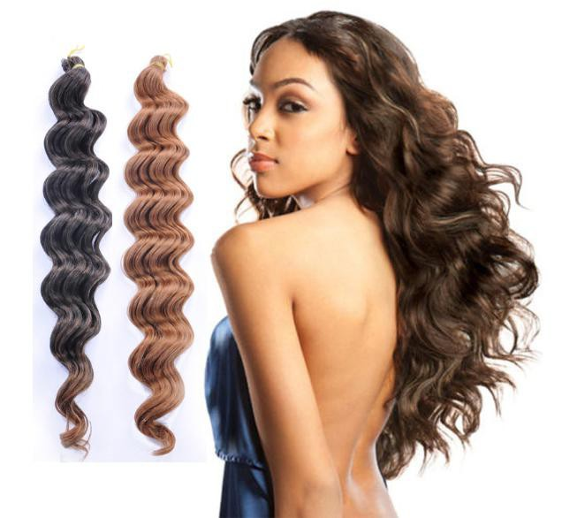 | 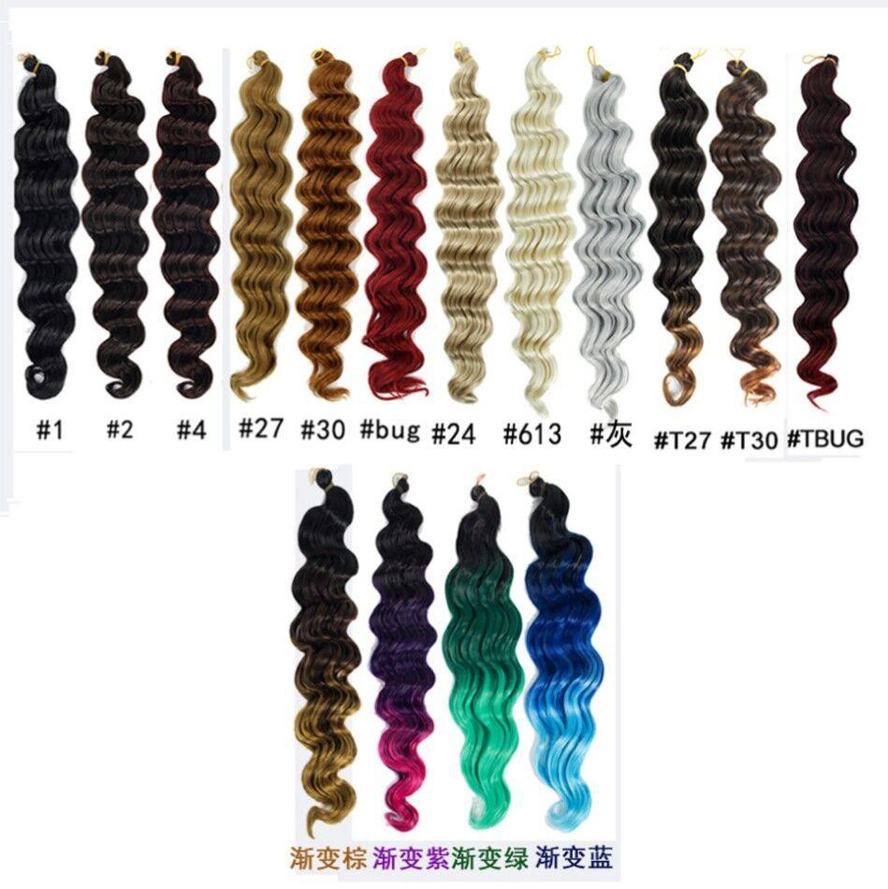 | Deep wave crochet braids | 18”,80g/pc  18”,80g/pc | #4 | $2.93/pc
14 | 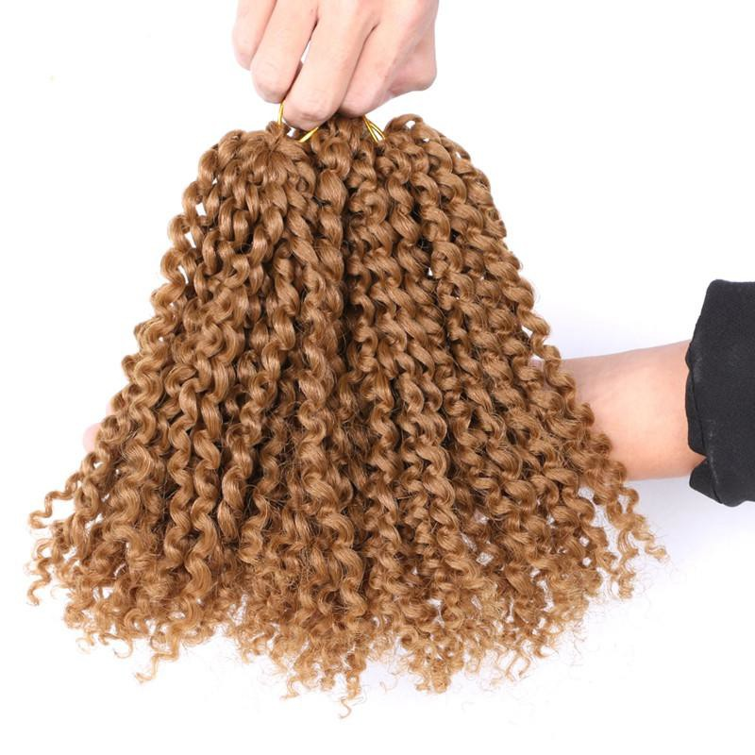 | 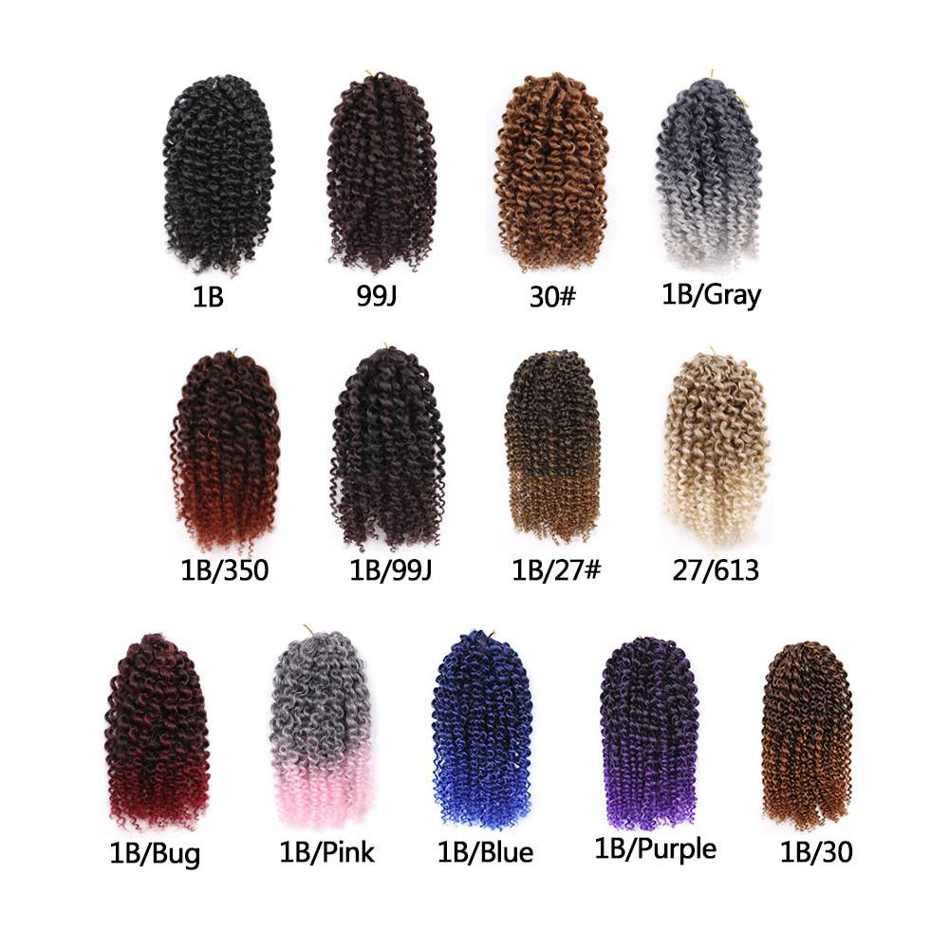 | Marlybob braids | 8”, 20 strands,90g/set | #1B/27 | $3.09/set(3pcs)
15 |  |  | Marlybob braids | 12”, 20 strands,105g/set | #1B | $3.39/set(3pcs)
16 |  | 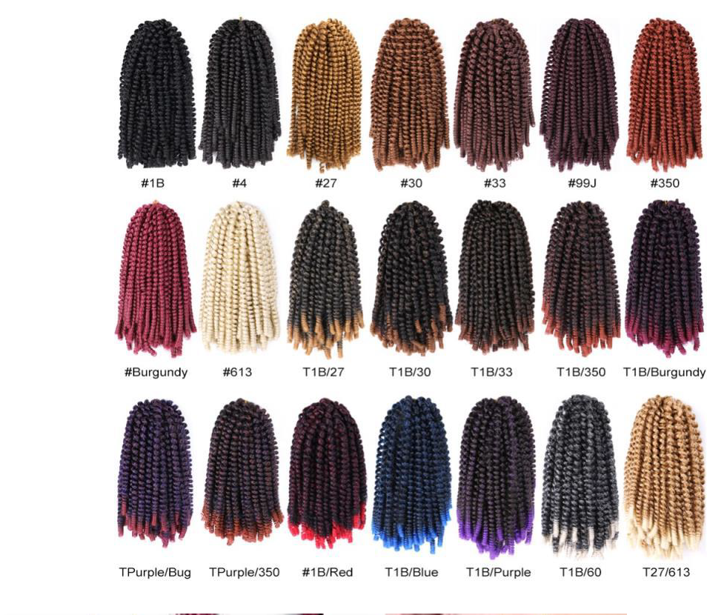 | Spring twist braids | 8", 30 Strands,110g/pc | #1B | $2.76/pc

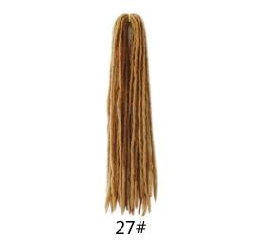
17 | 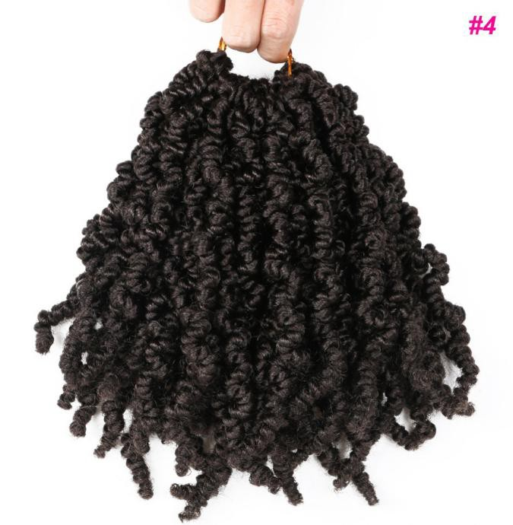 | 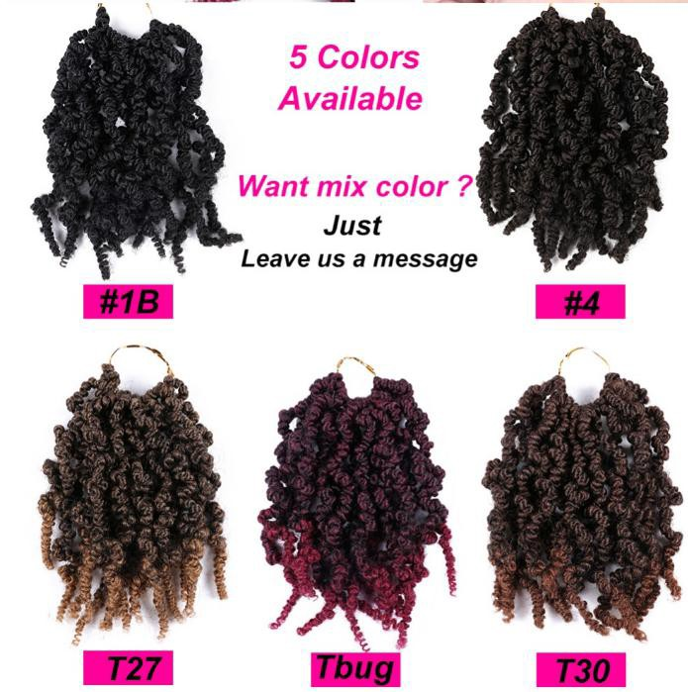 | Pre-twisted spring braids | 10", 15 Strands,85g/pc | #1B | $2.76/pc
18 | 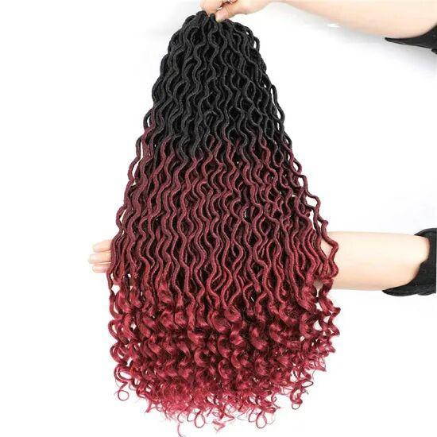 | 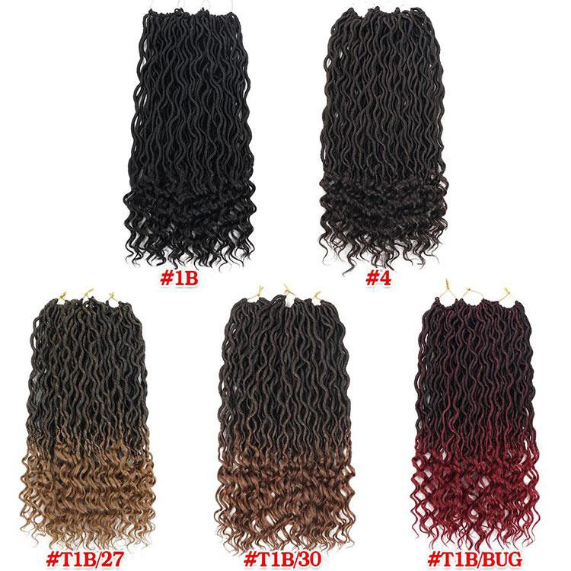 | Wavy goddess faux locs braids | 18", 24Strands,75g/pc | #1B | $2.89/pc;
19 | 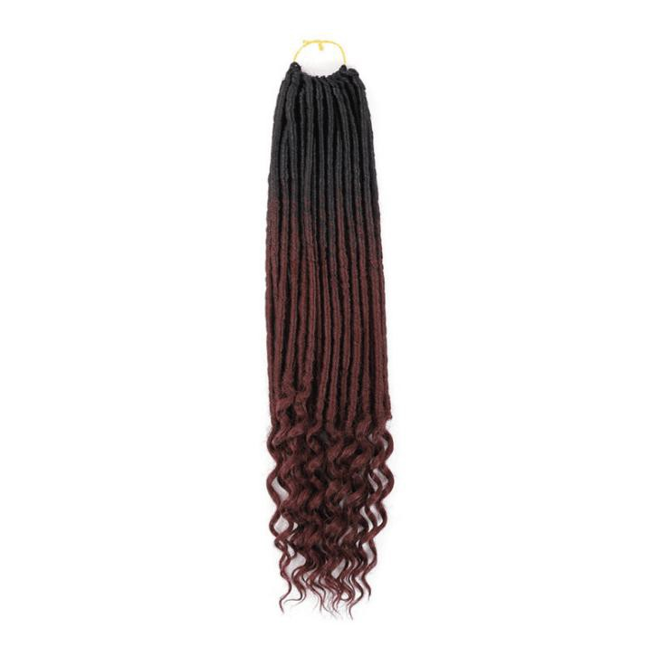 | 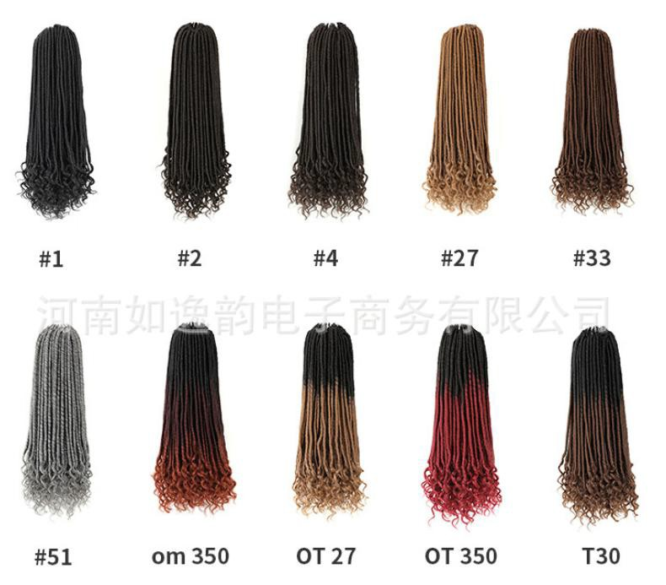 | Straight goddess faux locs braids | 18", 24Strands,75g/pc | #1B | $2.89/pc;
20 |  | 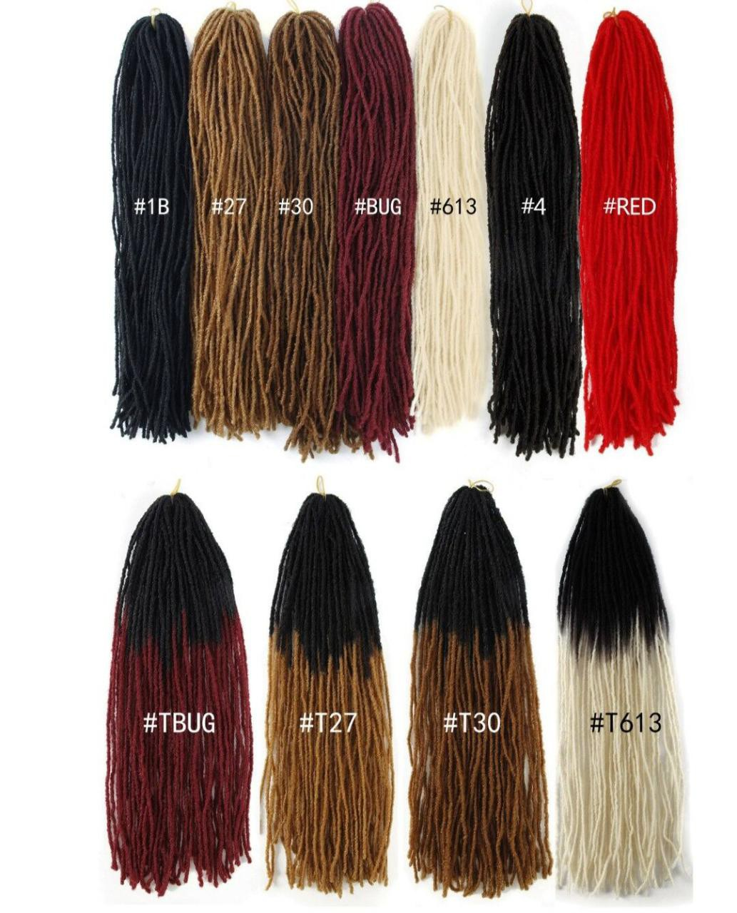 | Soft dreadlocs braids | 18", 18Strands,80g/pc, | #1B | $2.76/pc
21 | 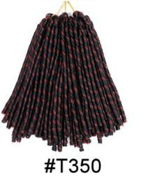 | 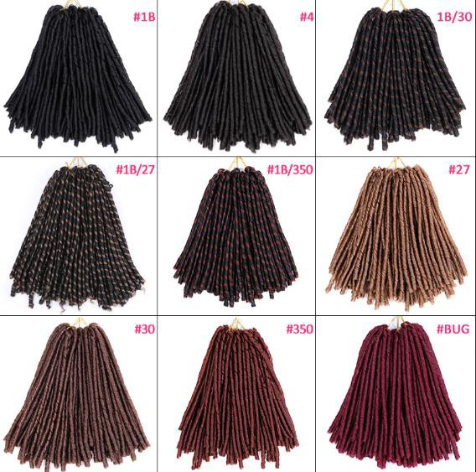 | Dreadlocks braids | 14", 30Strands,80g/pc, | #1B | $2.69/pc
22 | 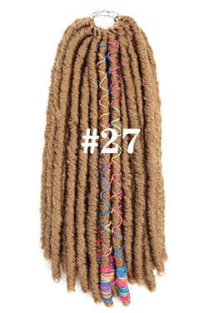 | 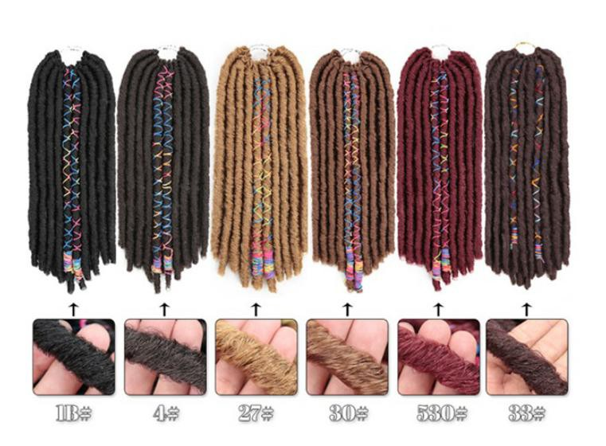 | Dreadlocks braids | 12", 20Strands,80g/pc, | #1B | $2.79/pc
23 |  |  |  |  | #27 | $2.79/pc
24 |  |  | Dreadlocks braids | 18", 20Strands,95g/pc, | #4 | $2.97/pc
25 |  |  |  |  | #30 | $2.97/pc
26 | 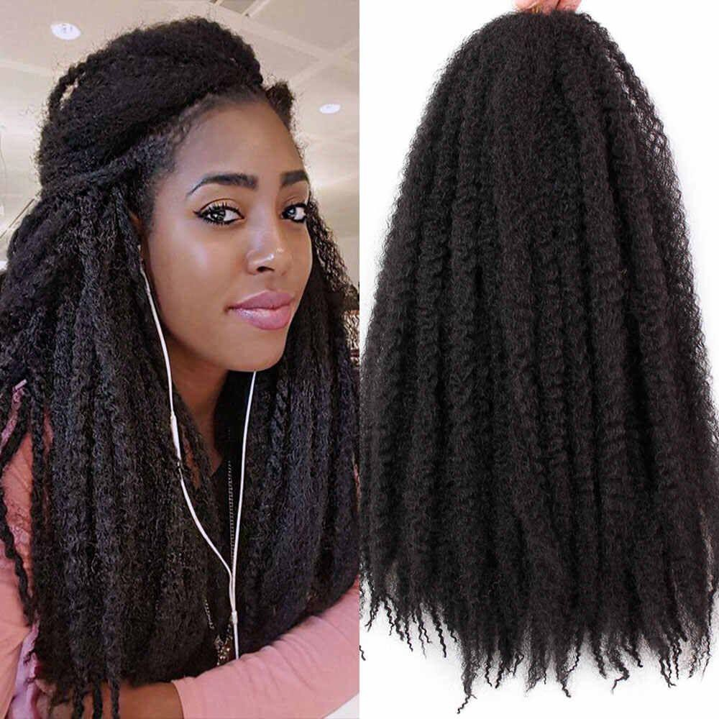 | 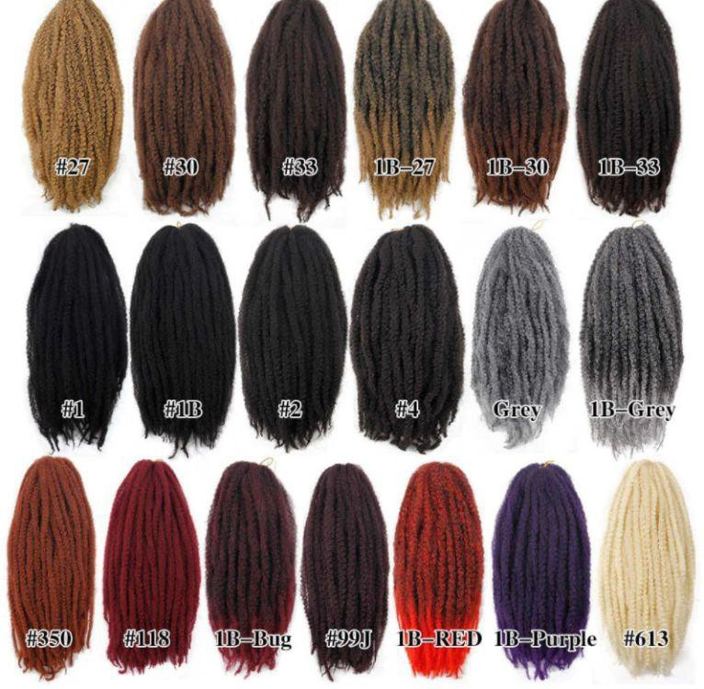 | Afro Marley braids | 18", 24Strands,100g/pc | #1B | $2.76/pc
27
28 | 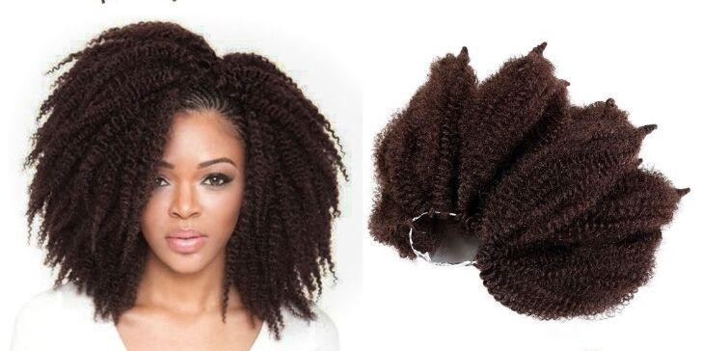 | 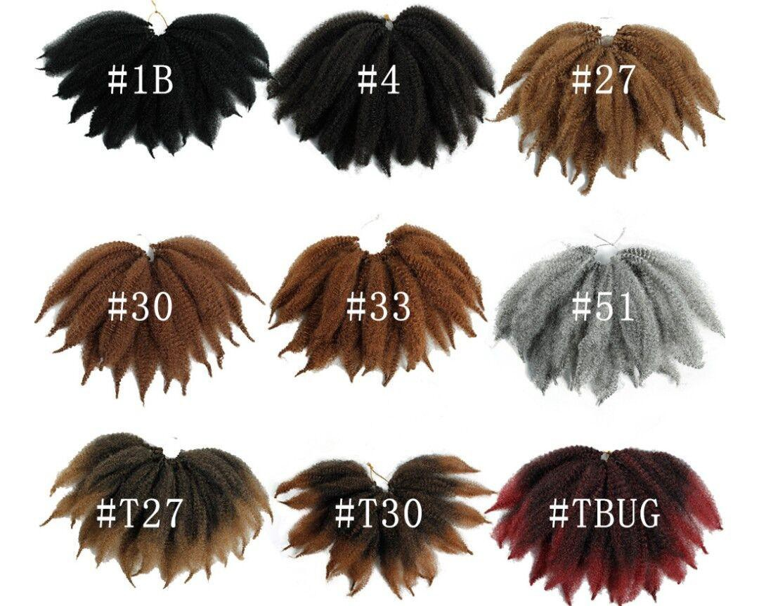 | Short Afro Marley braids | 8‘’14 Strands,40g/pc | #27 | $2.36/pc

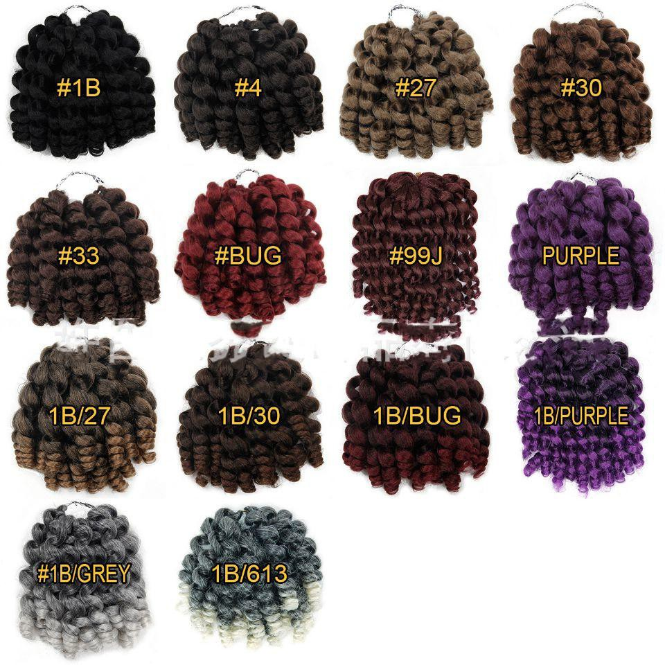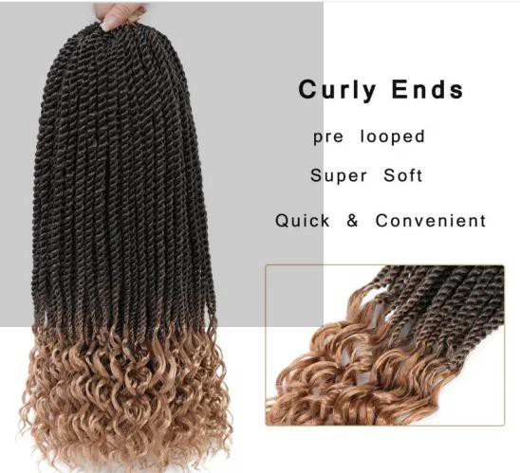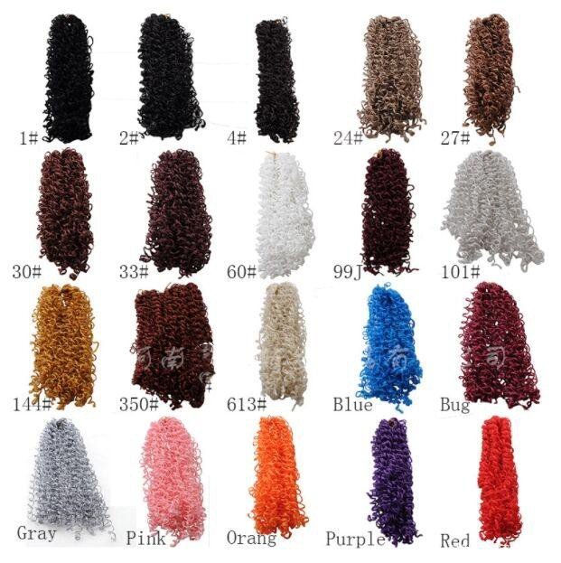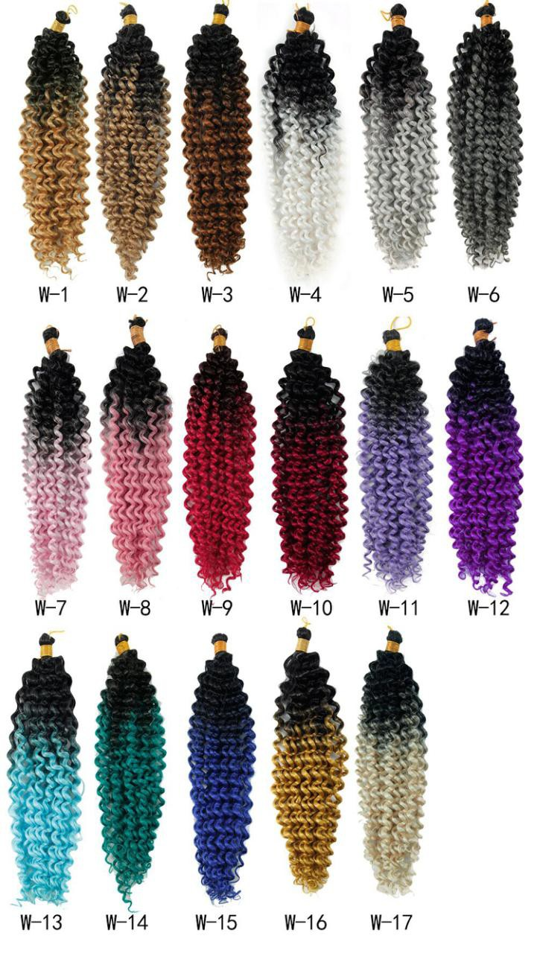
29 | 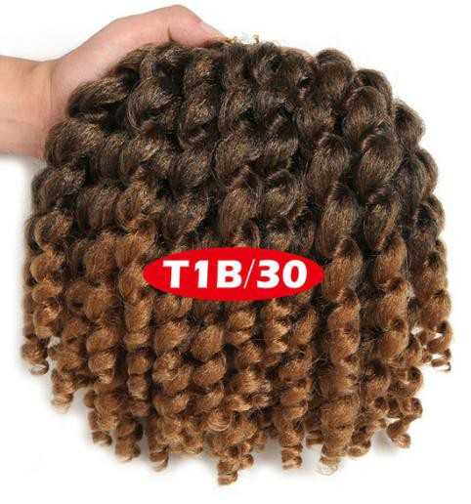 |  | Spring wand curl braids | 8'',20 Strands,80g/pc | #1B/27 | $2.56/pc
30 | 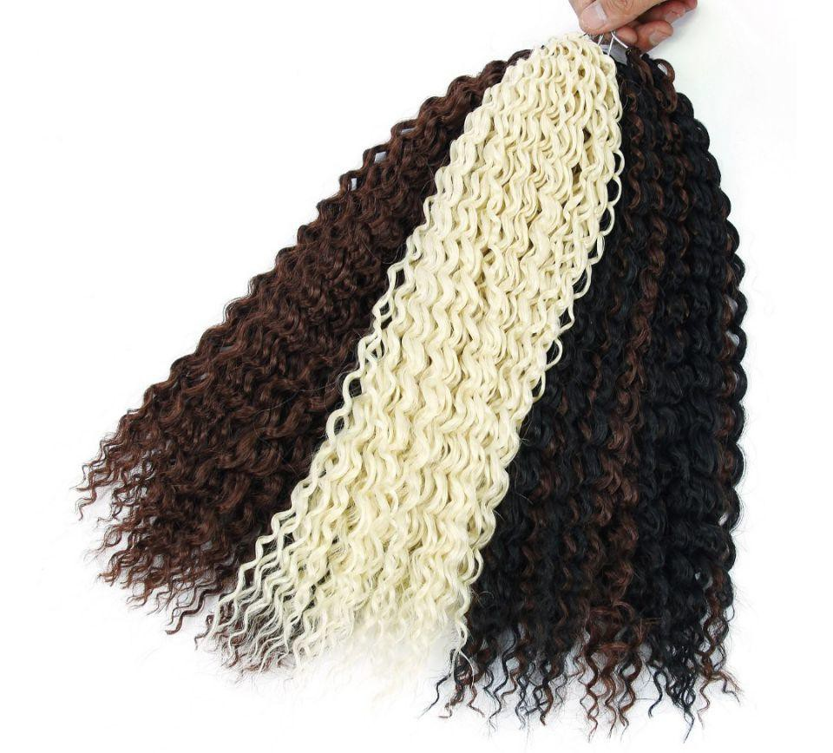 | 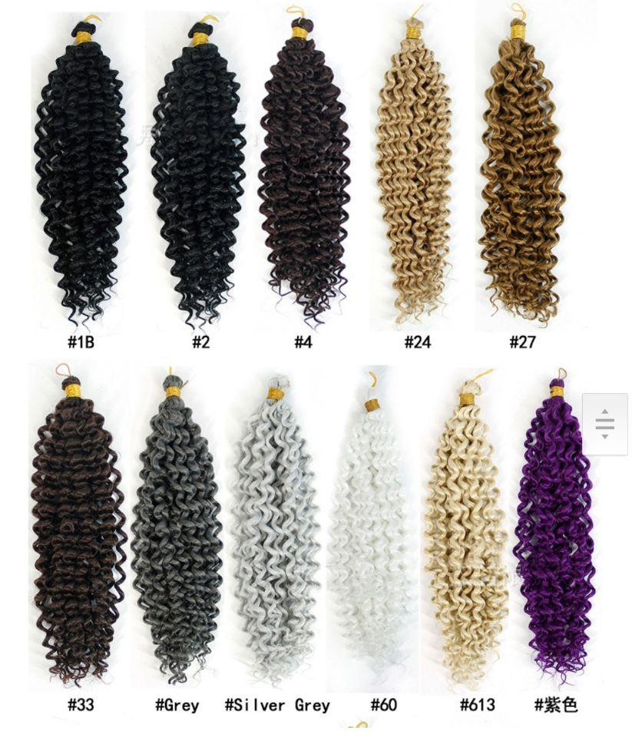 | Water wave crochet braids | 14‘',22 Strands,100g/pc | #1B | $2.79/pc
31 |  |  |  |  | W-1 | $2.86pc
32 |  |  | Water wave crochet braids | 18‘',22 Strands,110g/pc | #1B | $2.86/pc
33 |  |  |  |  | W-1 | $2.93/pc
34 | 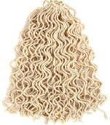 | 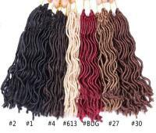 | Wavy faux locs braids | 18‘',224Strands,90g/pc | #2 | $2.86pc
35 | 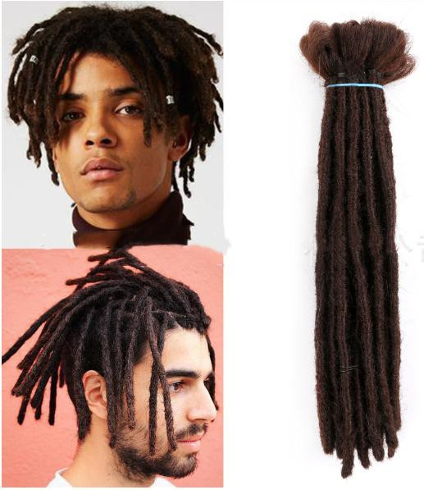 | 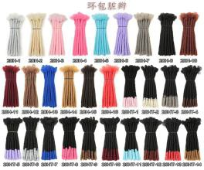 | Afro Dreadlocks braids | 12'', 2g/pc | 20HT-1 | $0.60/pc
36 | 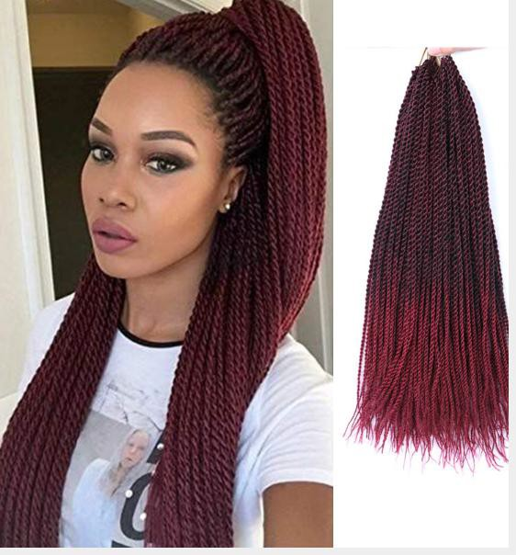 | 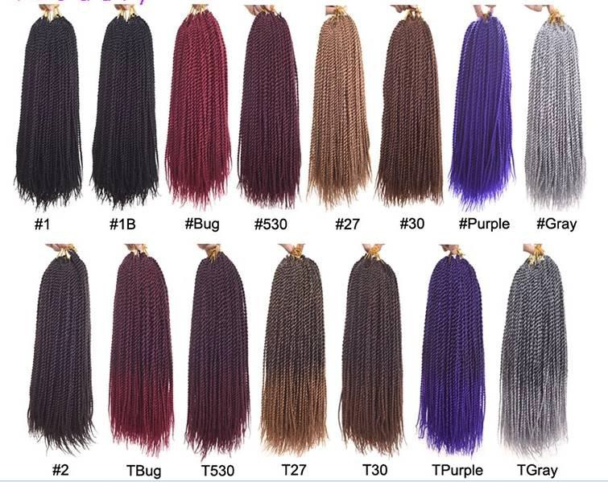 | Senegalese twist braids | 18‘',30Strands,90g/pc | #1B | $2.76
37 |  |  |  |  | #T27 | $2.76
38 |  |  | Senegalese twist braids | 24‘',30Strands,100g/pc | #1B | $2.81
39 |  |  |  |  | #T27 | $2.81
40 |  | 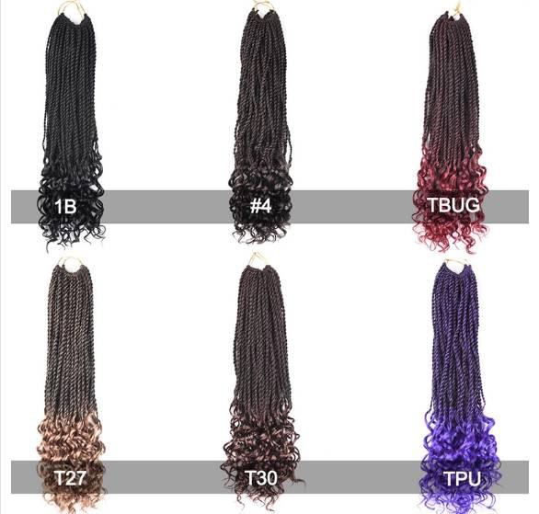 | Curly ends senegalese twist briaids | 18‘',30Strands,85g/pc | #1B | $2.89
41 | 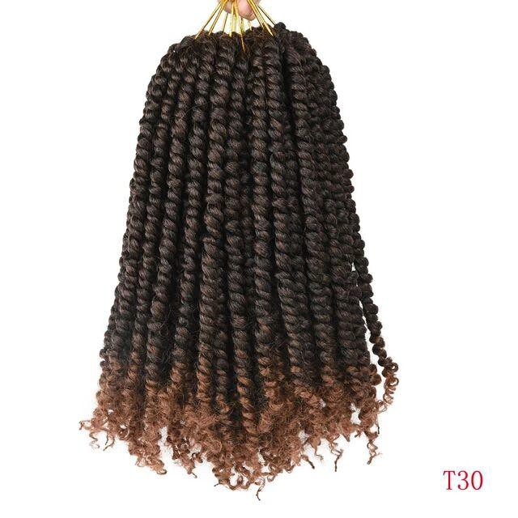 | 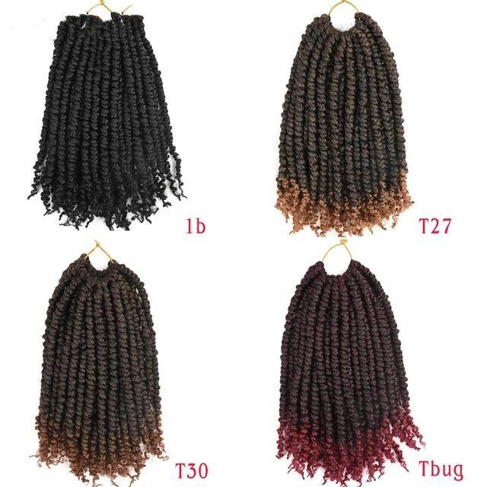 | Pre-twisted senegalese braids | 16'', 12 Strands, 80g/pc | #1B | $3.09/pc
42 | 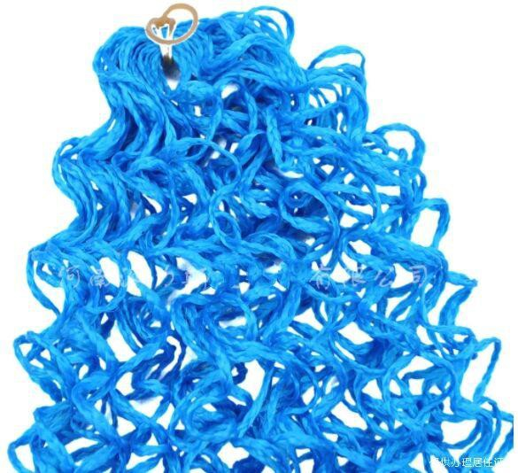 |  | Zizi Box Braids | 18'',28 Strands,50g | #1 | $2.97pc

43 Passion twist braids 18”,22 Strands 80g/pc #1B $2.76/pc

44 Passion twist faux locs braids 20”,24 Strands,100g/pc #1B $3.26/pc

Pre-twisted
45
passion braids 18‘’,14 Strands,100g/pc #1B/27 $3.05/pc

46 #2 (One-color style)
18'', $2.81/pc

47 Gypsy faux locs braids 18''24 Strands,100g/pc
$$3.13
#1B/277 (Two-color)

48 #C5 (Three-color) $3.26

49 14'', 24 Strands, 80g/pc #1B $3.43/pc

Pre-looped river goddess crochet braids

50 18’’, 24 Strands, 95g/pc #1B/30 $3.89/pc

51 14", 20 Strands 80g/pc #1B $2.98/pc

52 River goddess box twist braids
18", 20 Strands 90g/pc #1B $3.09/pc

53 24", 20 Strands 105g/pc #1B $3.25/pc

12", 20 Strands 80g/pc
54

#27
12", $3.09/PC

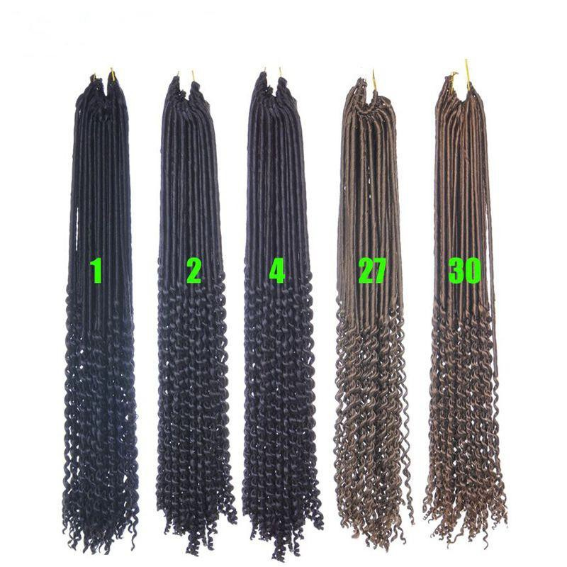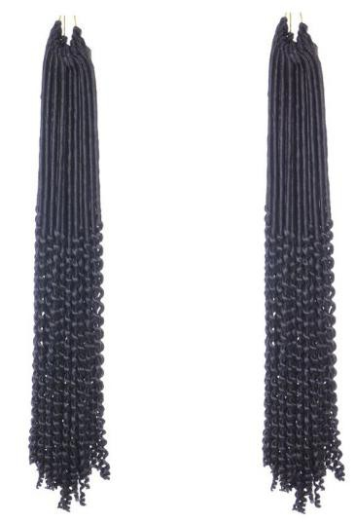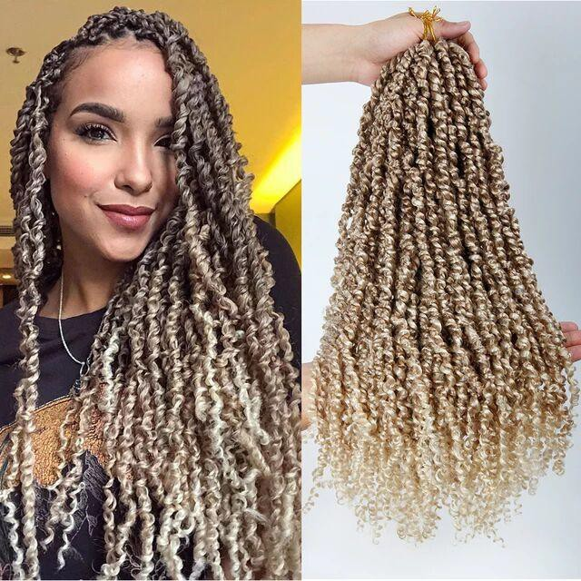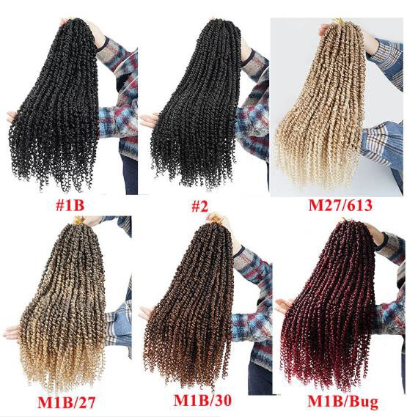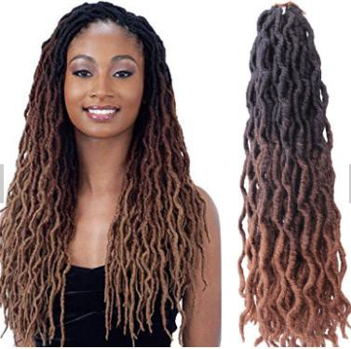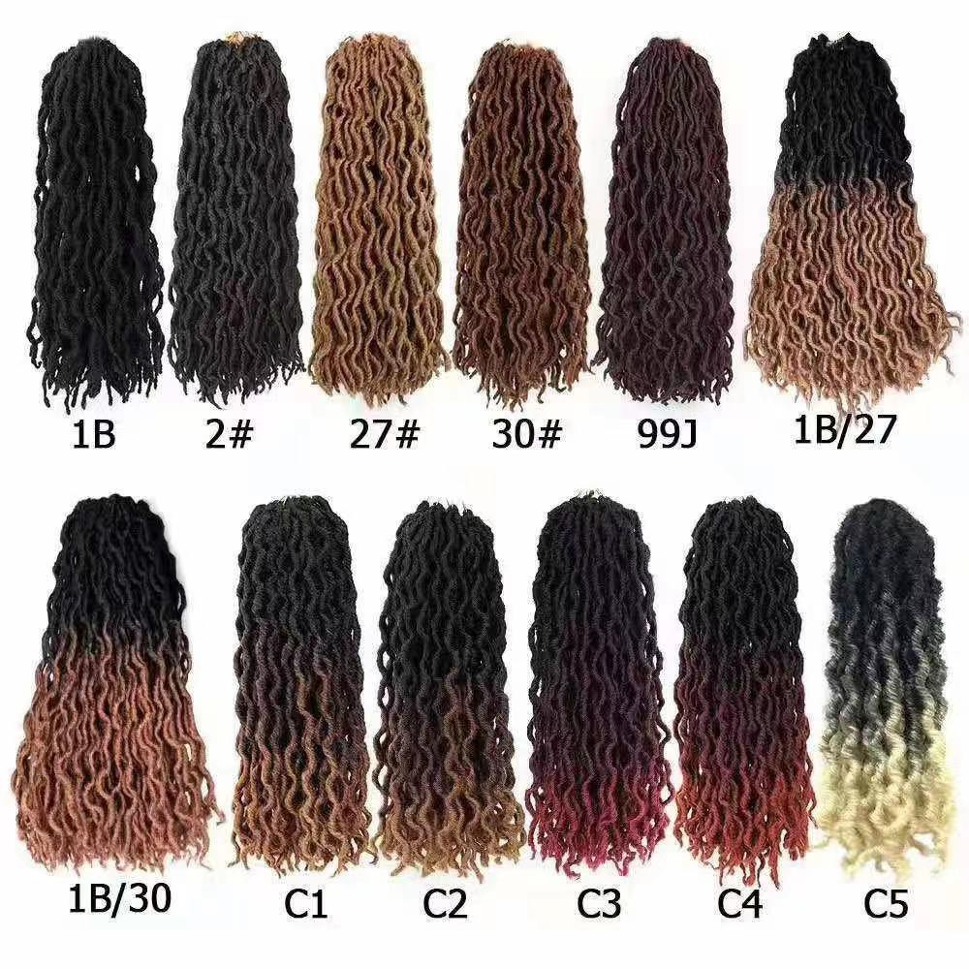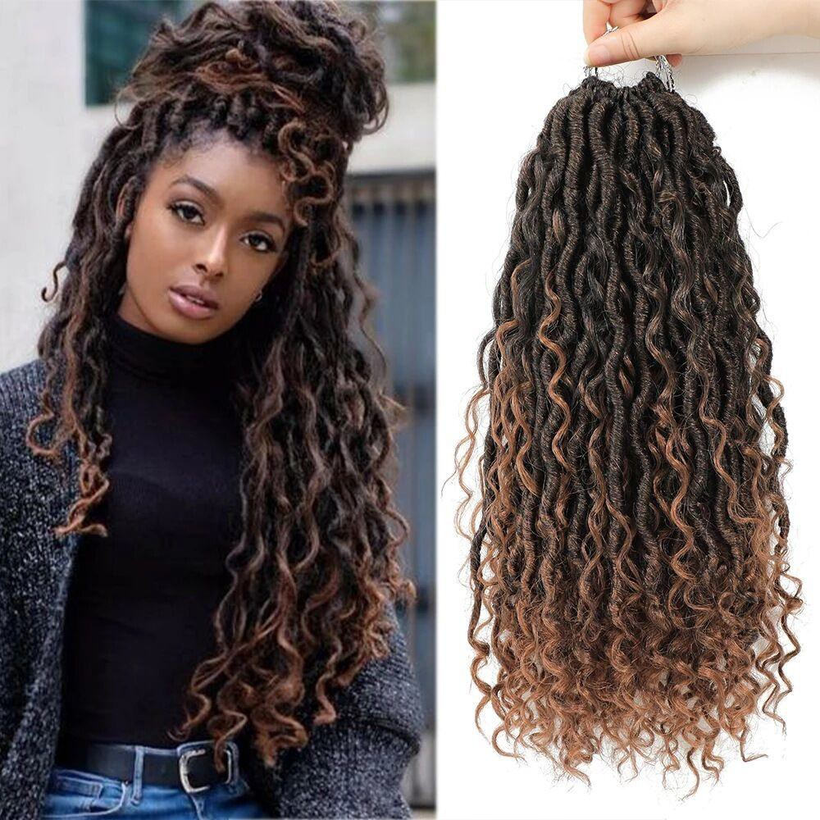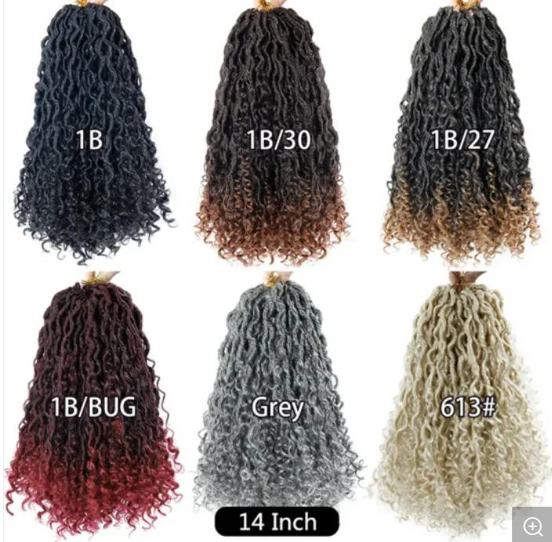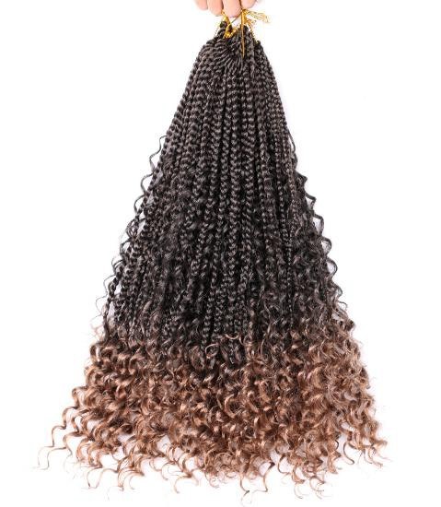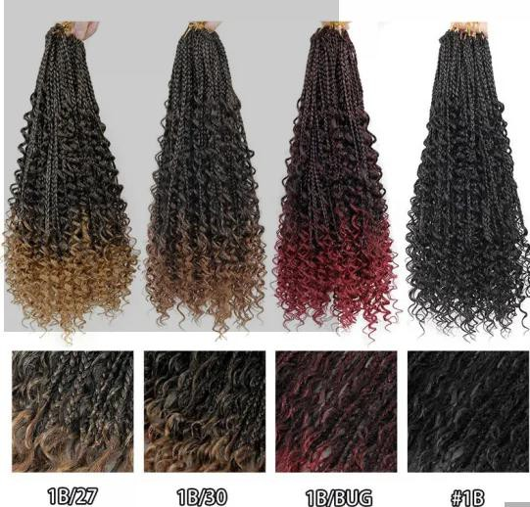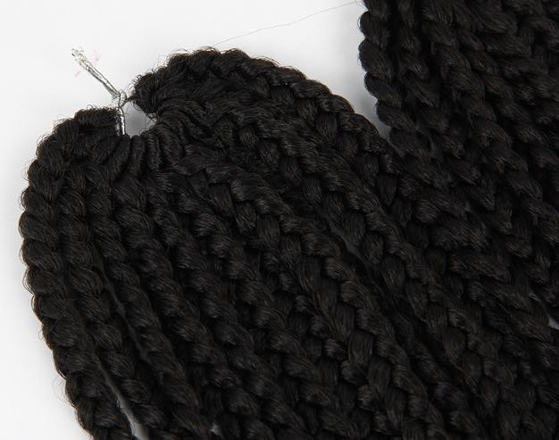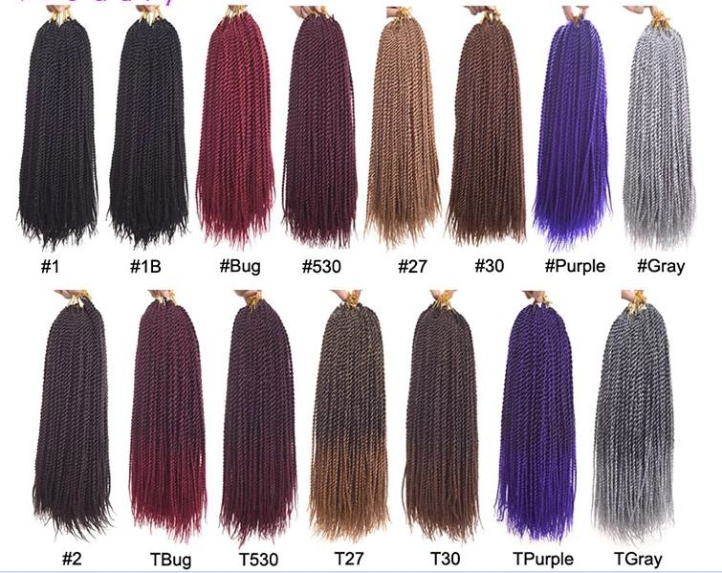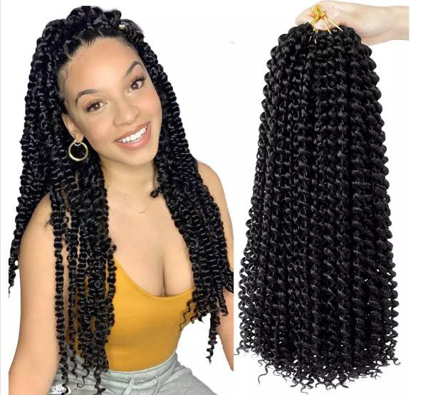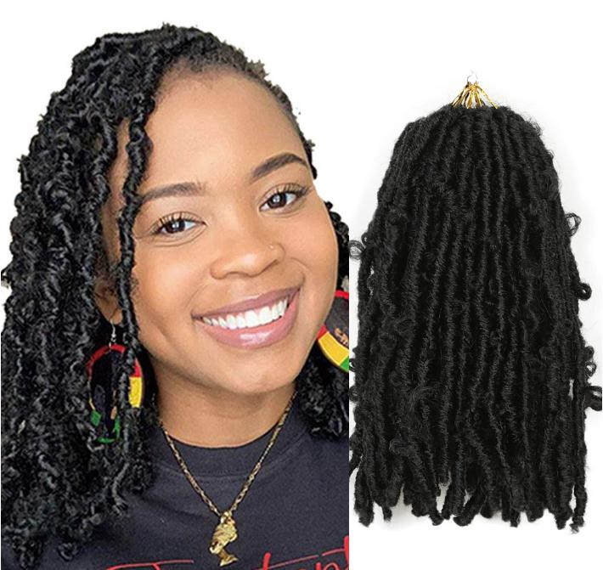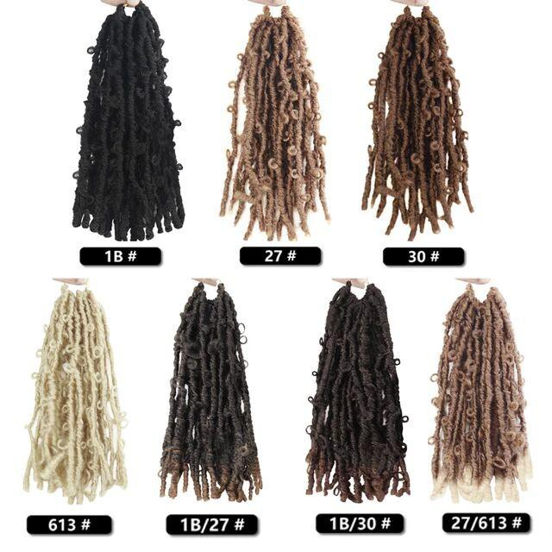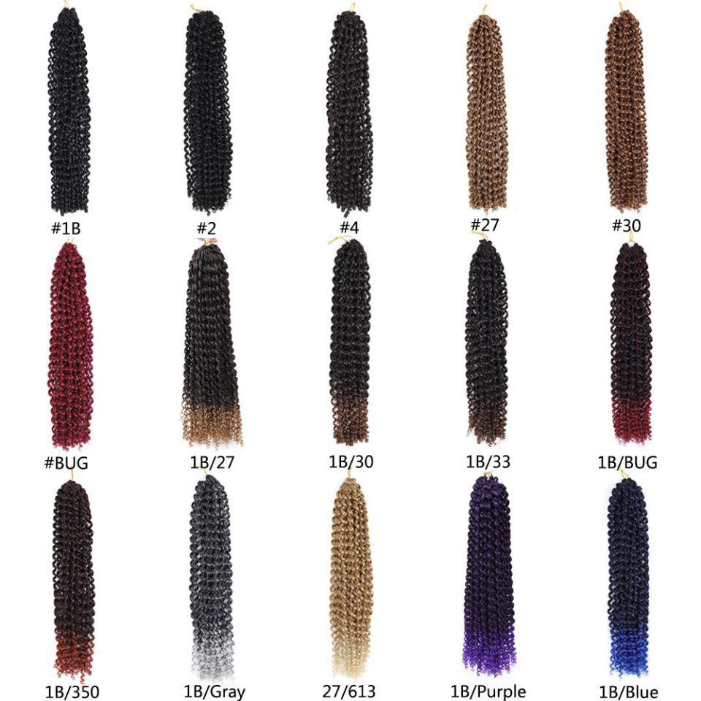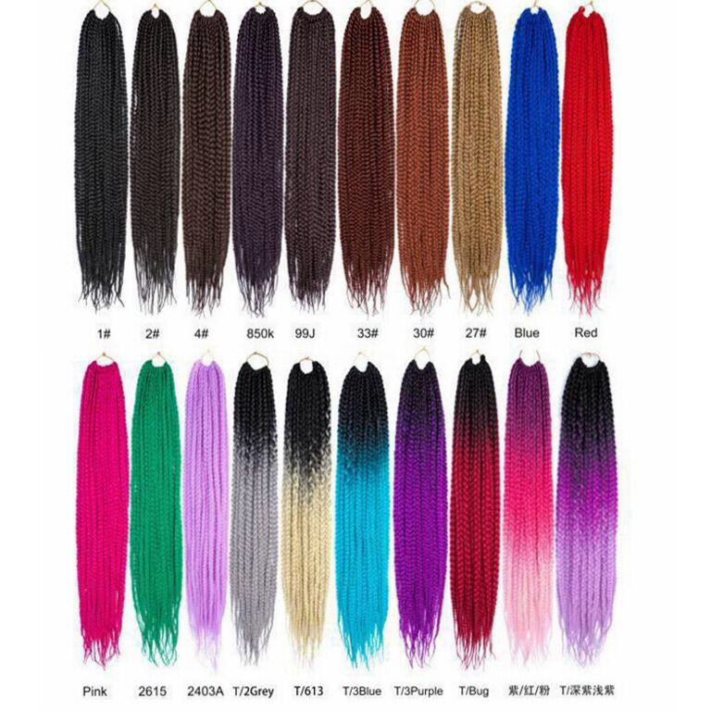
Butterfly locs braids

55 18", 20Strands 120 g/pc #30 18", $3.46/PC

56 Box twist braids 24", 22 Strands 105g/pc #1B 24"，$2.85/pc

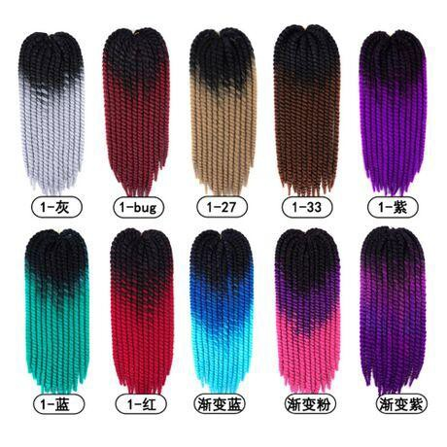
57 | 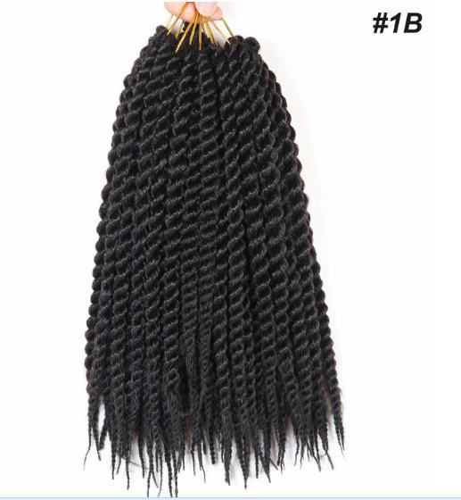 | 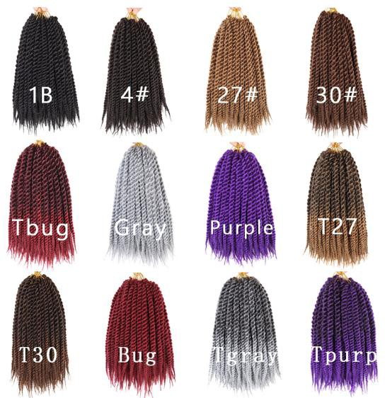 | Thick senegalese twist braids | 12‘’ 12 Strands,80g/pc | #1B | $2.36/pc
58 | 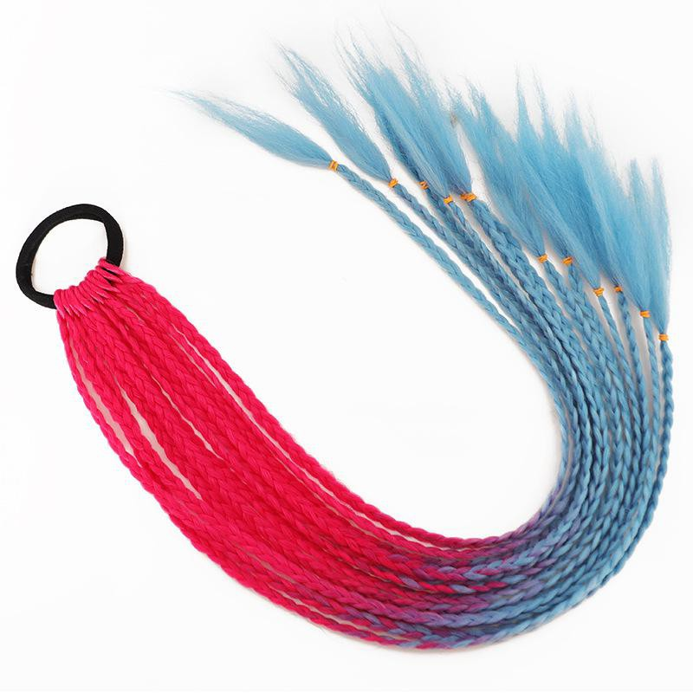 | 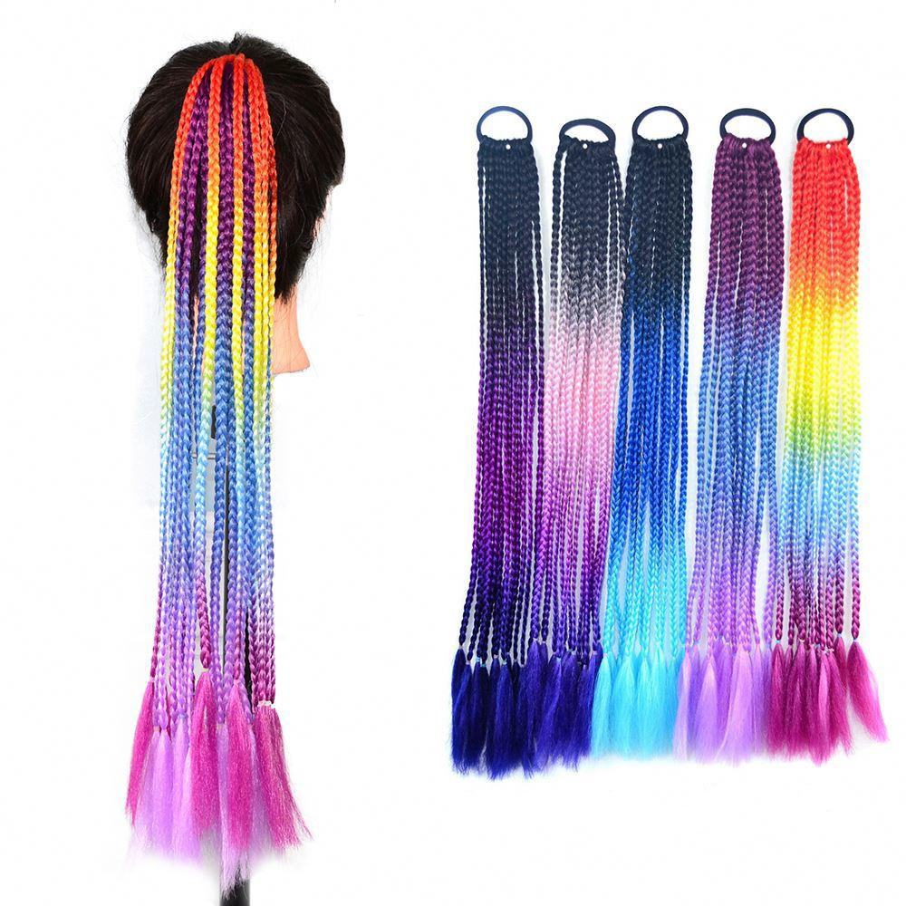 | Box braiding ponytail | 24'',12 Strands,55g/pc | #1B | $1.61/pc
59 | 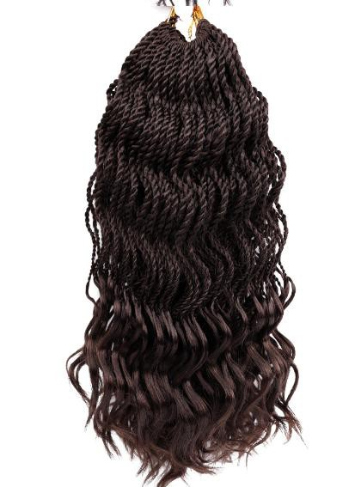 | 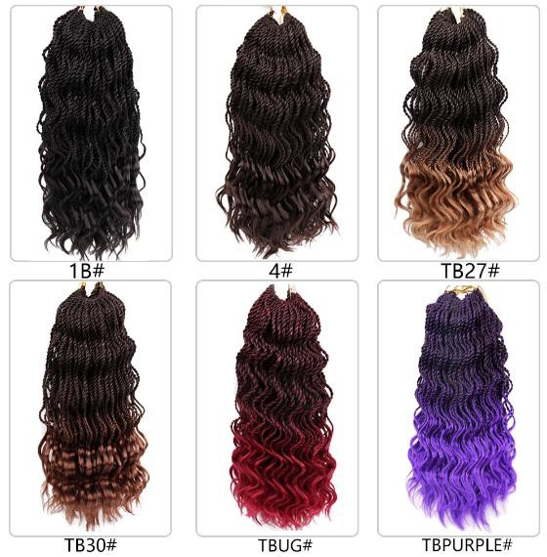 | Wavy senegalese braids with curly ends | 14", 35 Strands 85g/pc | #1B | $2.89/pc
60 | 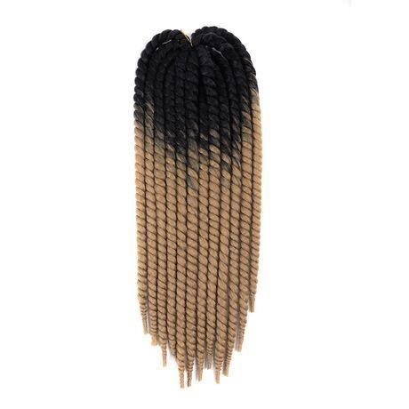 |  | Havana mombo twist braids | 24", 12 Strands 115g/pc | #1B (One-color) | $2.59/pc
61 |  |  | Havana mombo twist braids | 24", 12 Strands 115g/pc | #1-27 (Two-color) | $2.81/pc
62 |  |  | Havana mombo twist braids | 24", 12 Strands 115g/pc | #Black.Purple,Pink(Three- color) | $2.95/pc
63 | 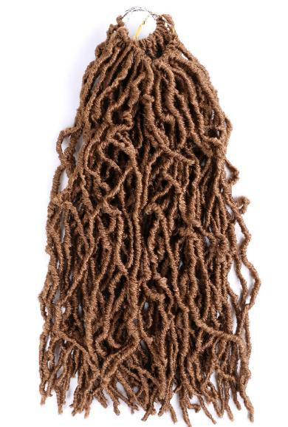 | 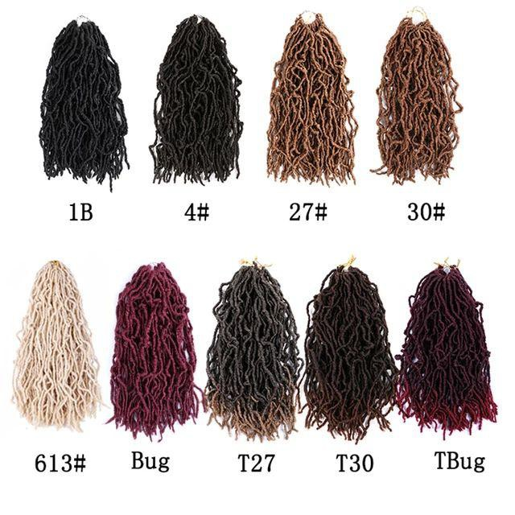 | Nu locs braids | 18", 21 Strands 90g/pc | #1B | $2.89/pc
64 |  |  | Nu locs braids | 24", 21 Strands 120g/pc | #27 | $3.03/pc
65 | 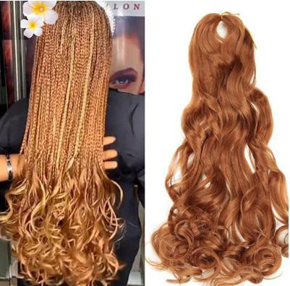 | 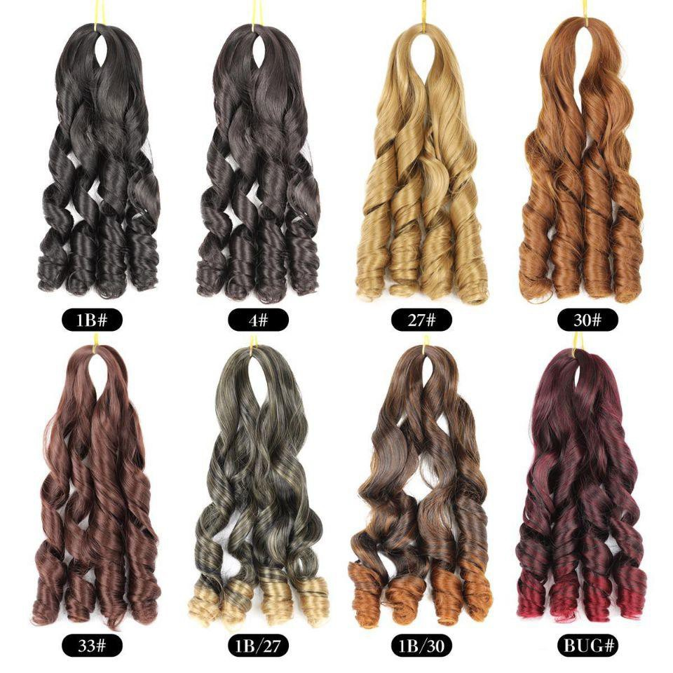 | Spiral wave crocht braids | 24'', 75g/pc | #1B | $2.23/pc
66 | 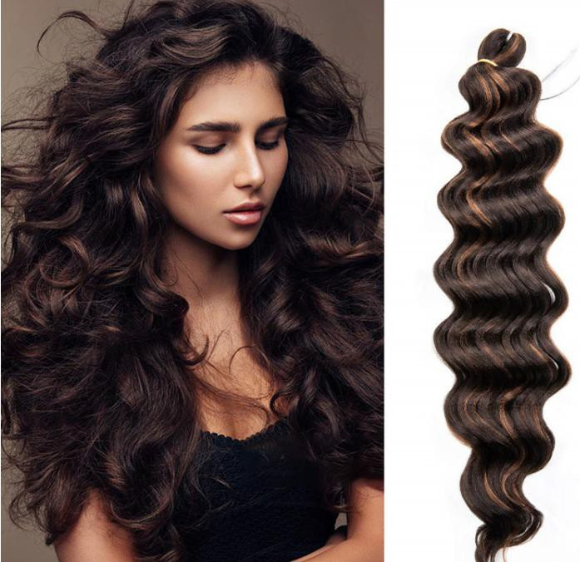 | 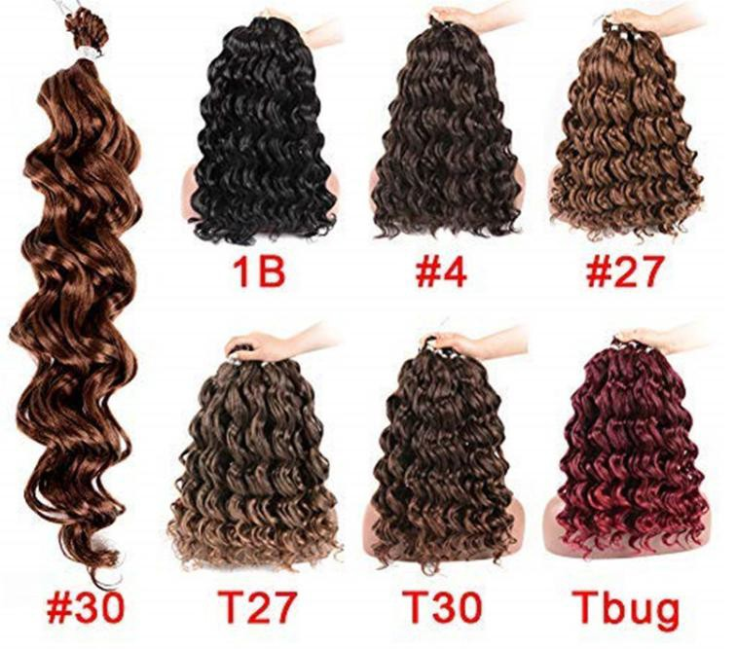 | Ocean wave crocht braids | 18'', 70g/pc | #1B | $2.69/pc
67 | 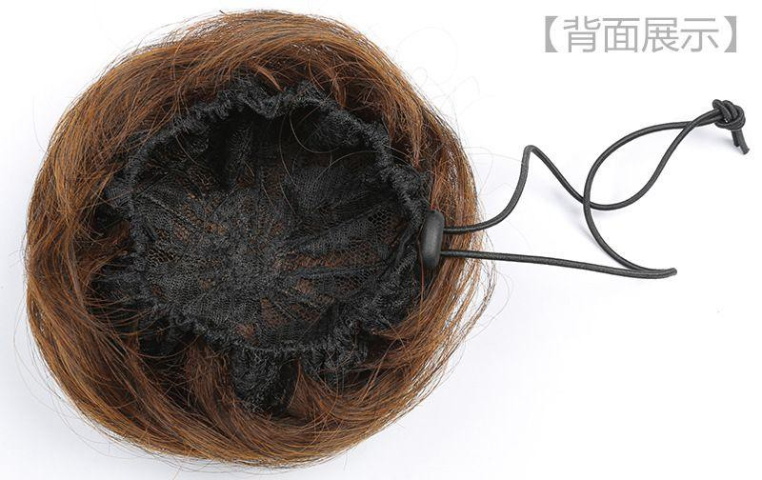 | 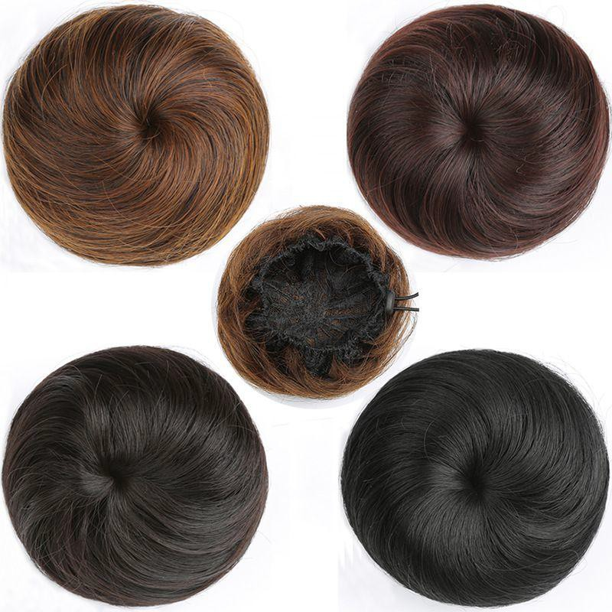 | Drawstring bun | 3‘’,30g/pc | #Brwon | $2.69/pc

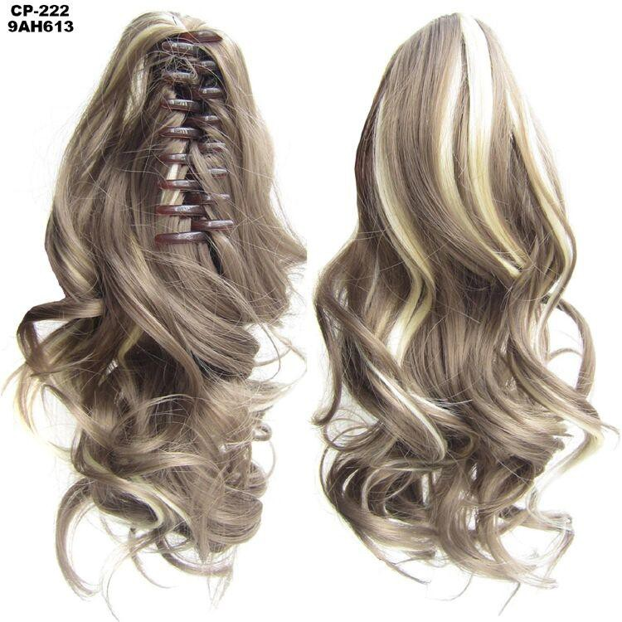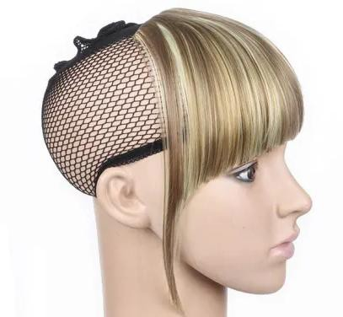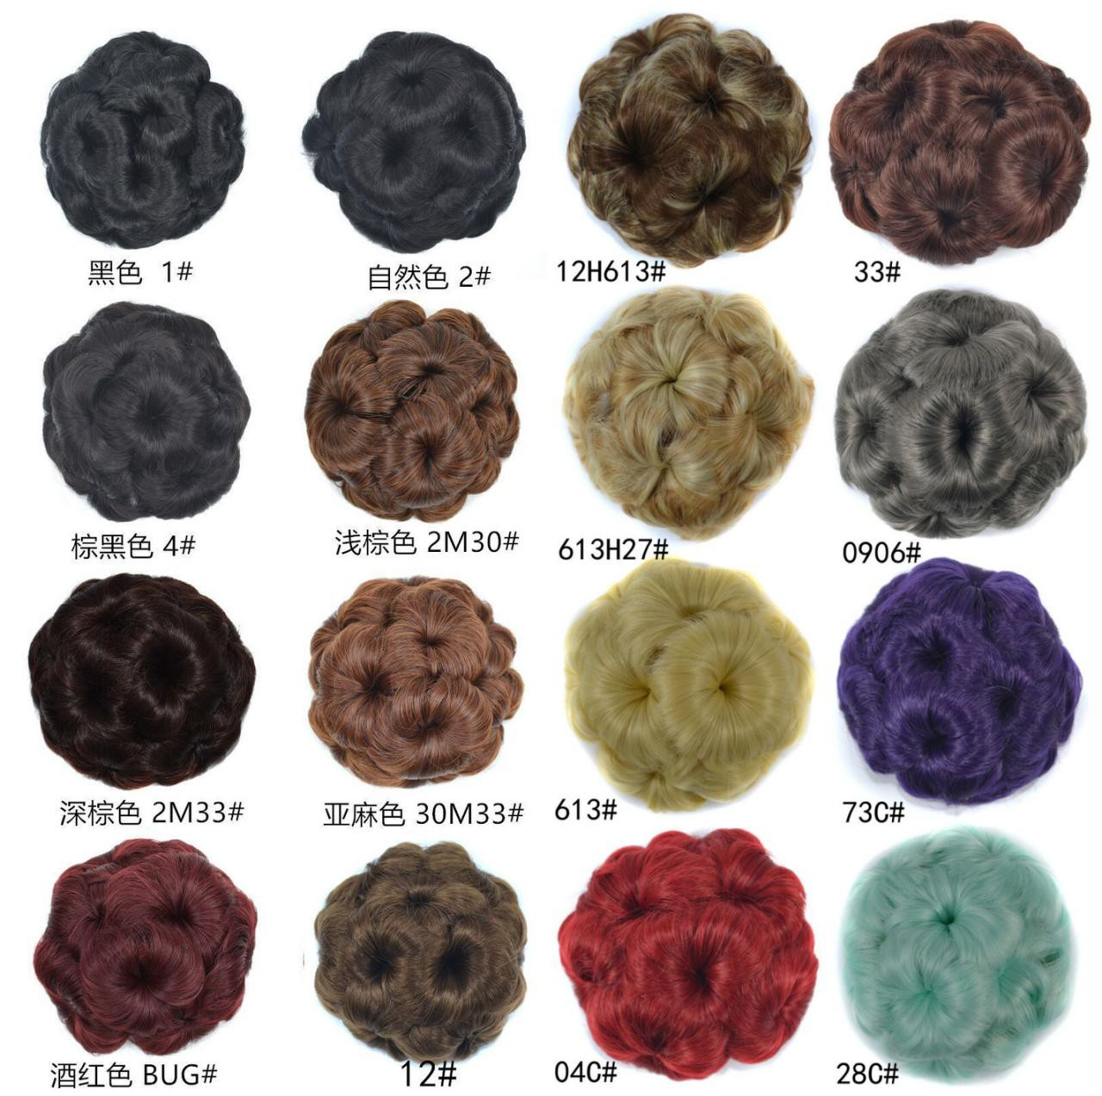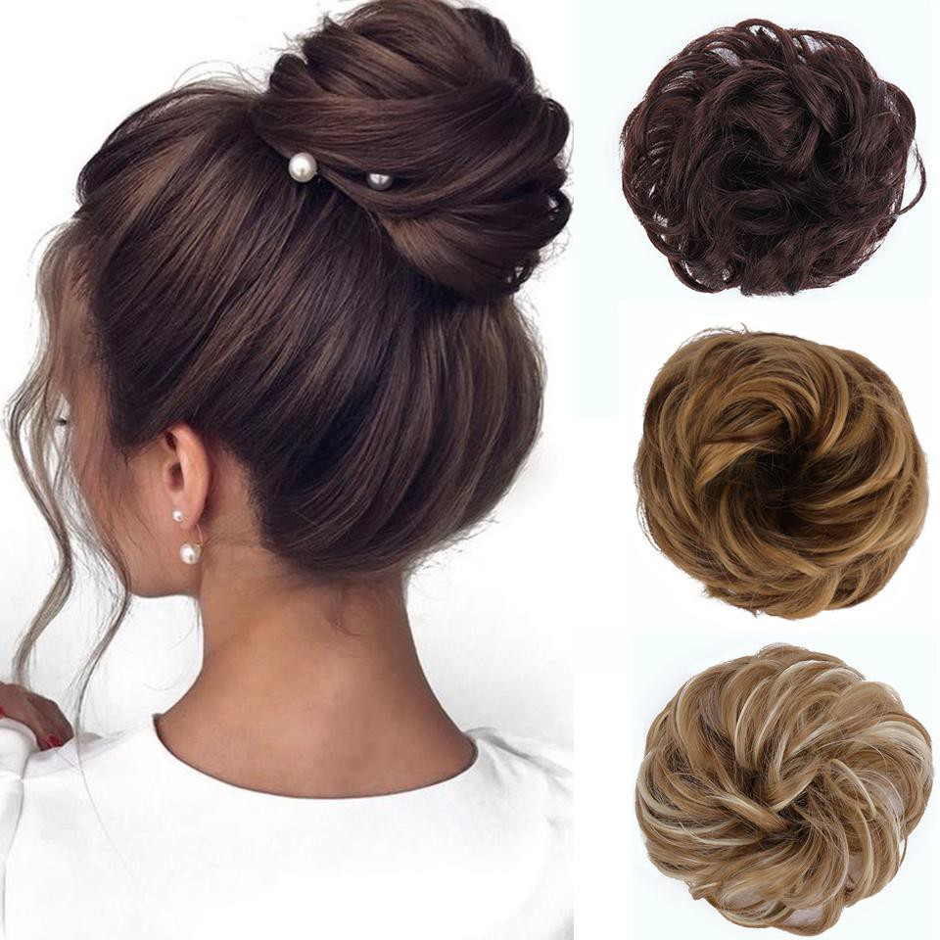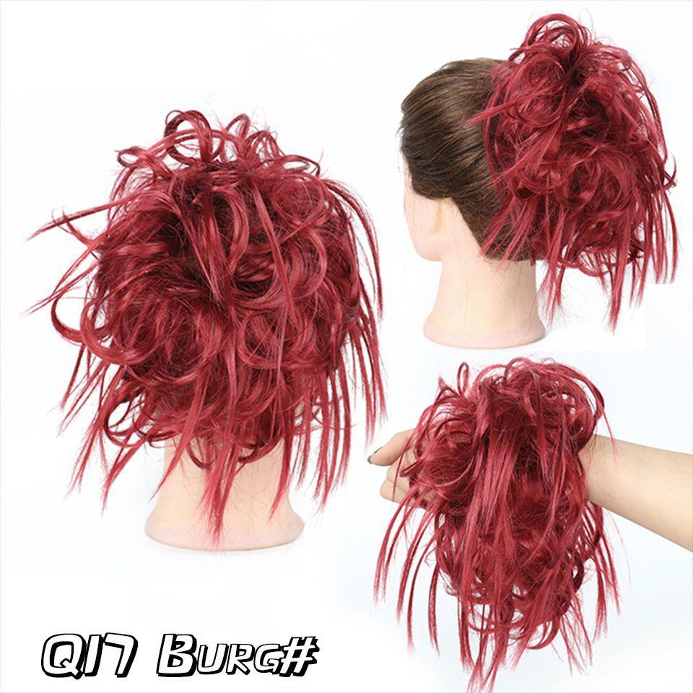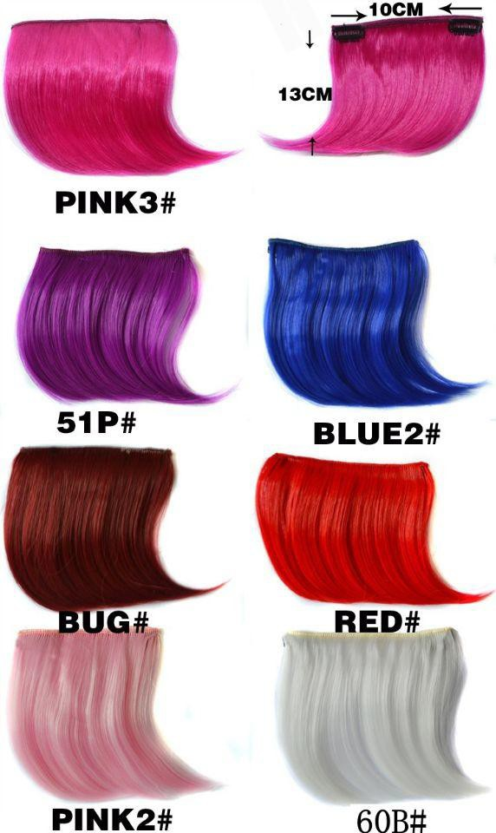
68 | 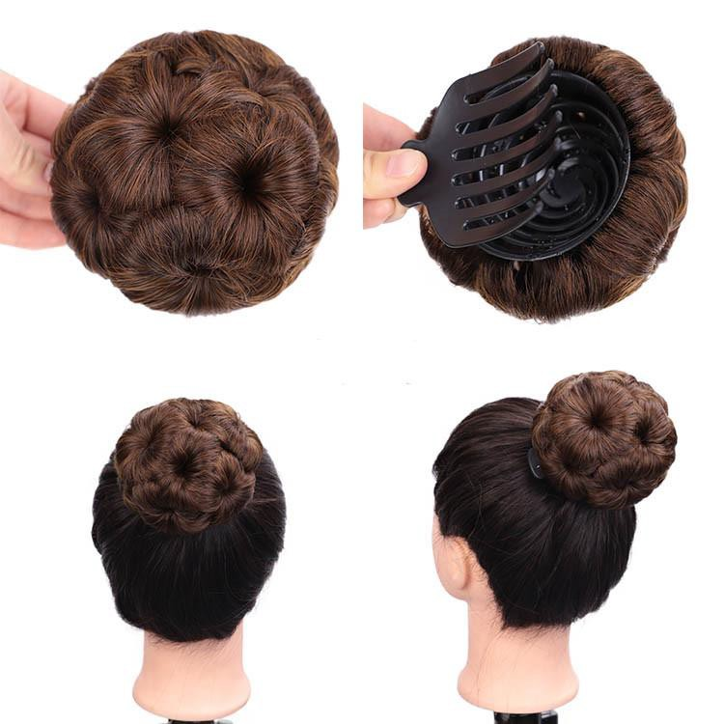 |  | Clip in bun | 12*7cm, 75g/pc | #1 | $1.88/pc
69 |  | 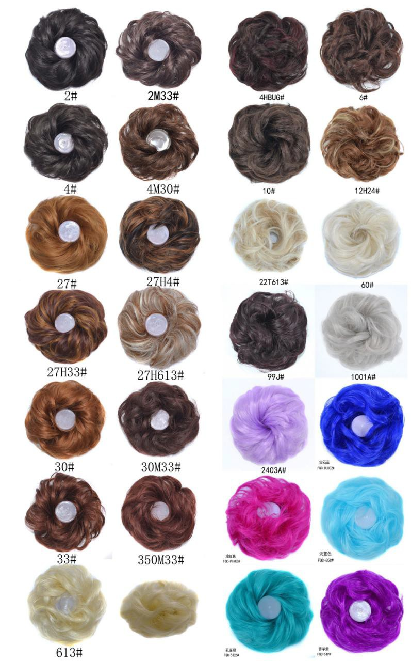 | Hair ring | 14*6cm, 27g/pc | #Blue | $1.88/pc
70 |  | 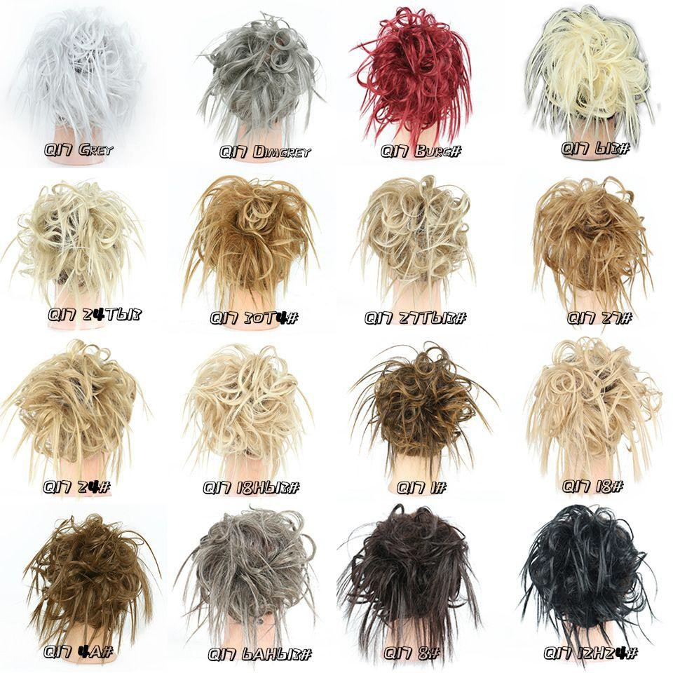 | Tousled Messy Bun | 7'', 45g/pc | #Bug | $2.35/pc
71 | 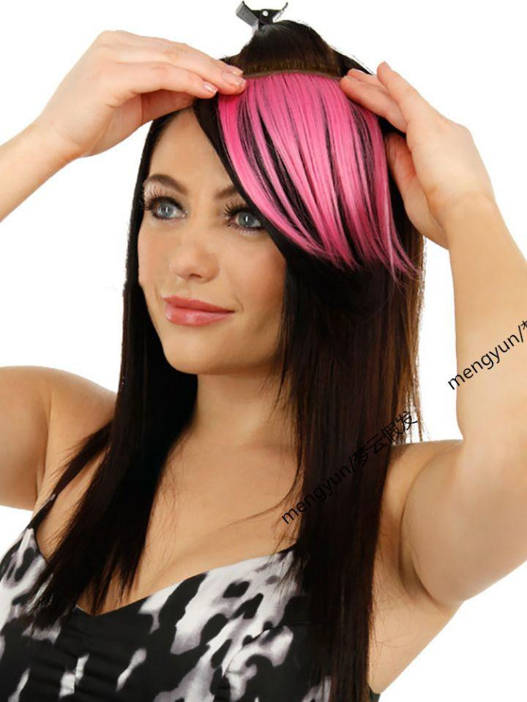 |  | Hair bangs  Hair bangs | 10*14cm, 7g/pc | #Pink 3 | $1.41/pc
72 | 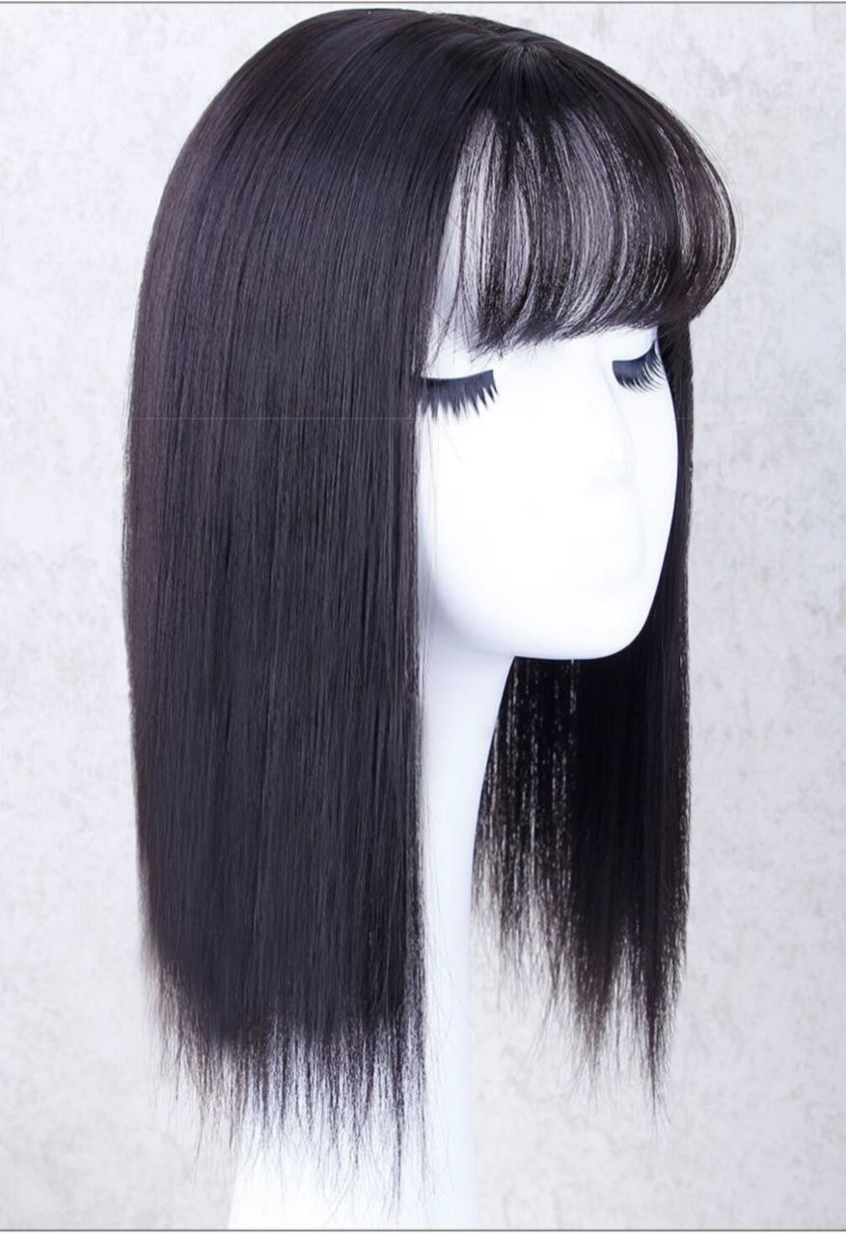 | 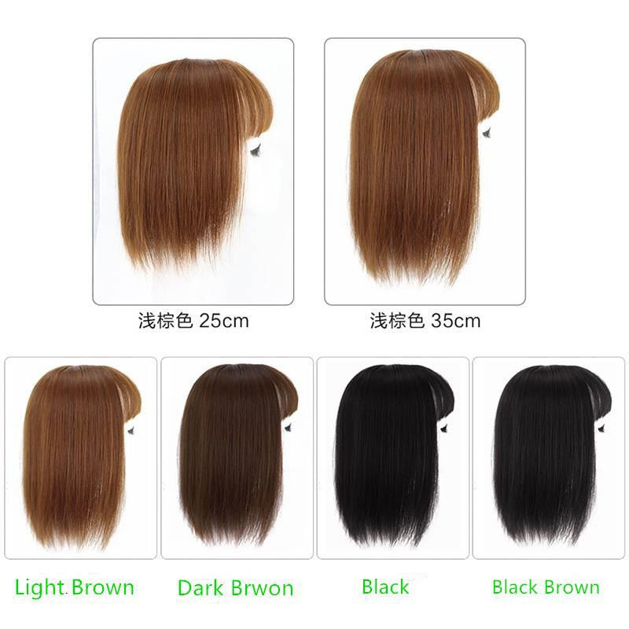 | Hair bangs  Hair bangs | 25cm or 35cm,45g/pc | #Dark brwon | $2.79/pc
73 |  | 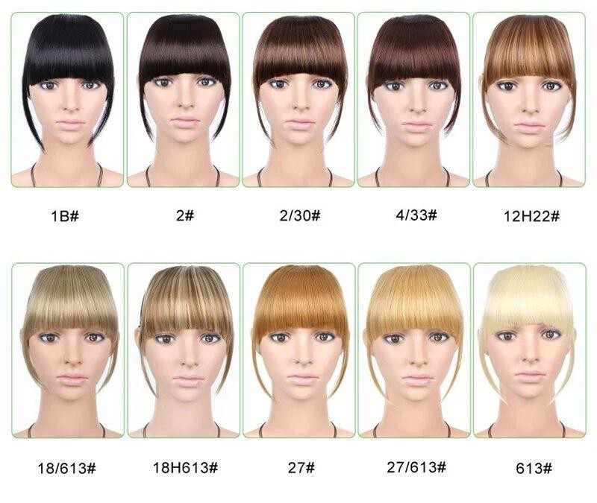 | Hair fringe bangs | 15.5cm,30g/pc | #1B | $2.35/pc
74 |  | 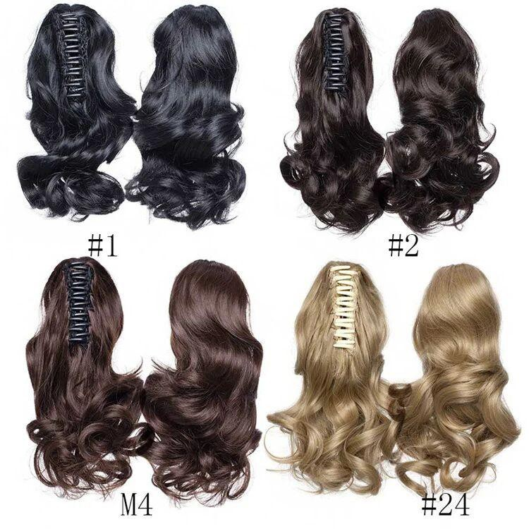 | Body wave claw clip in ponytail | 16‘’，90g/pc | #2 | $2.85/pc
75 | 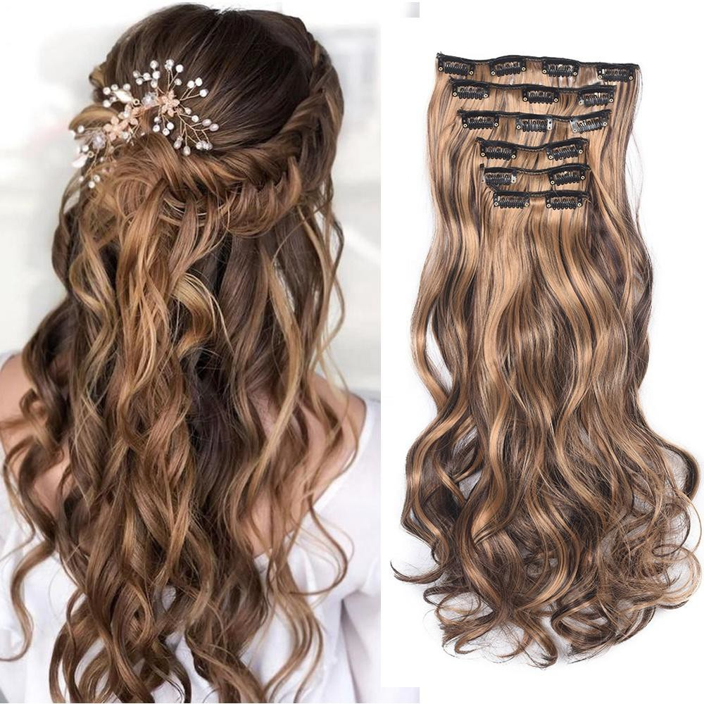 | 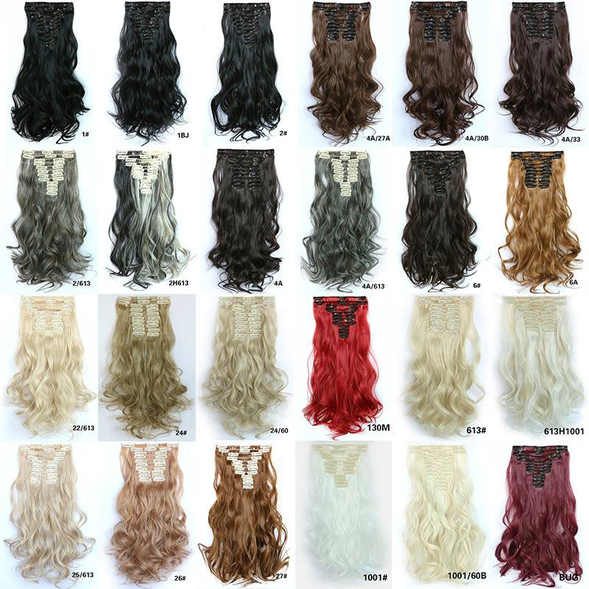 | Natural wave clip in ponytails set(6pcs) | 20'', 140g/pc | #1 | $3.45/set

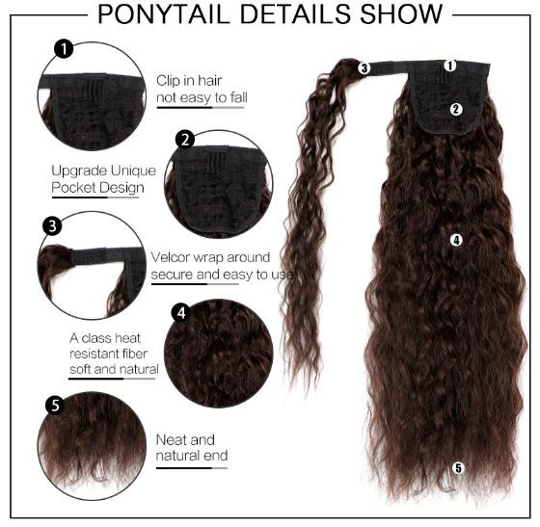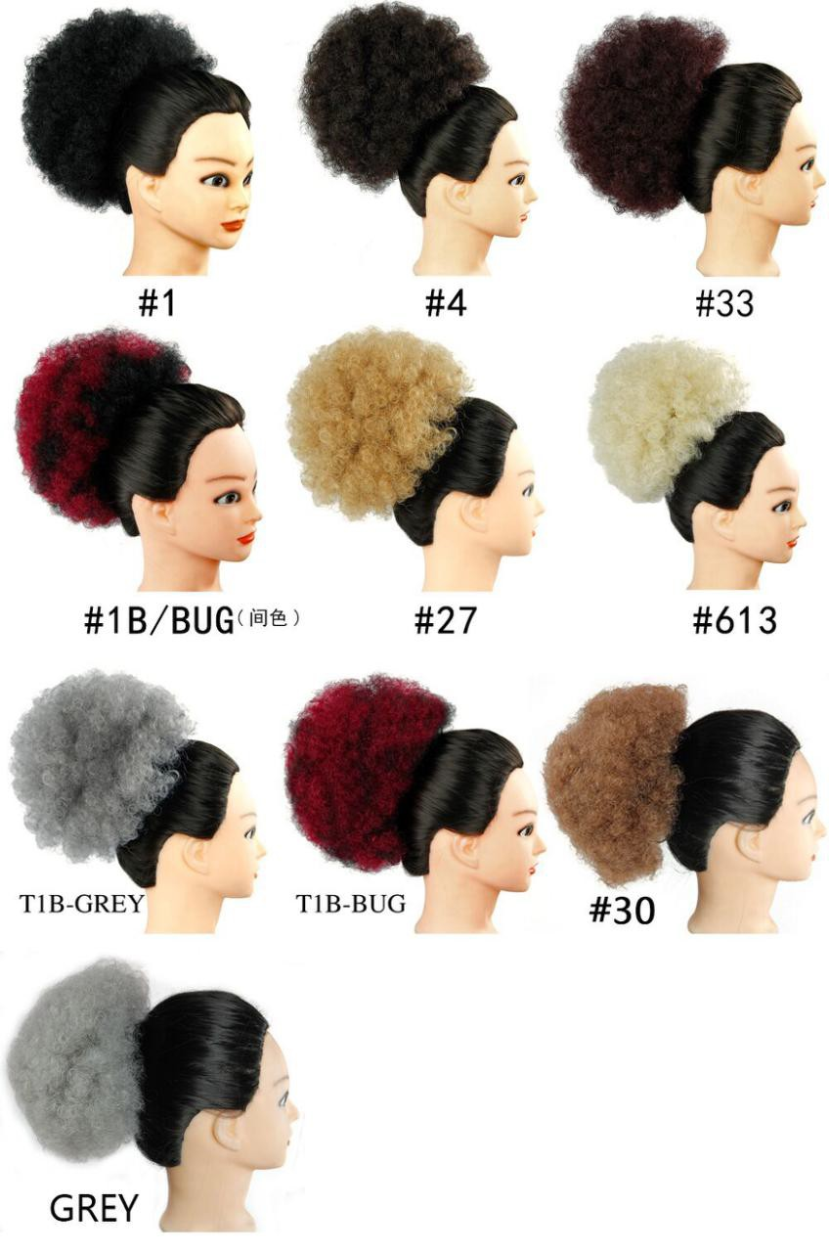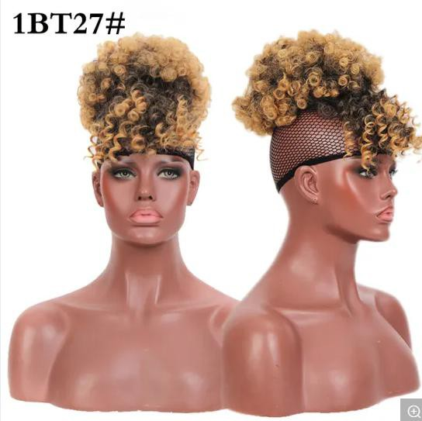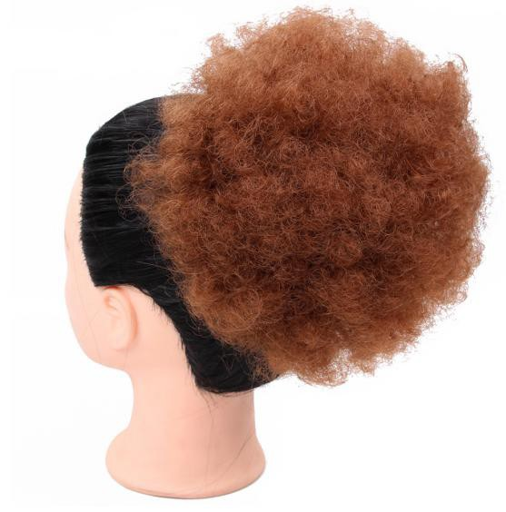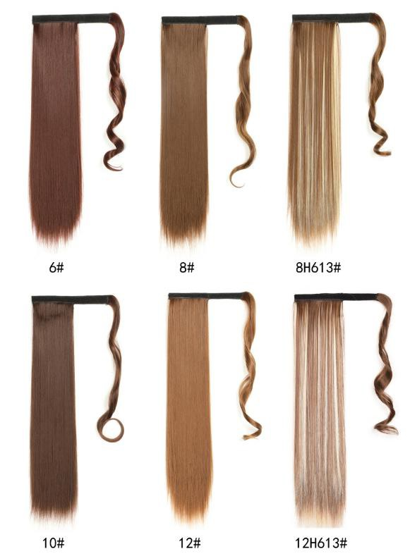
76 | 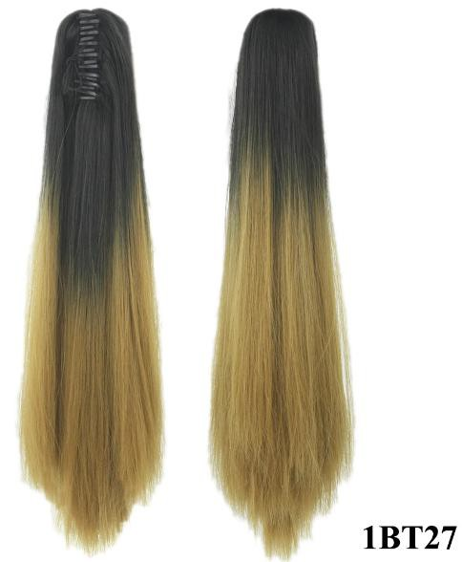 | 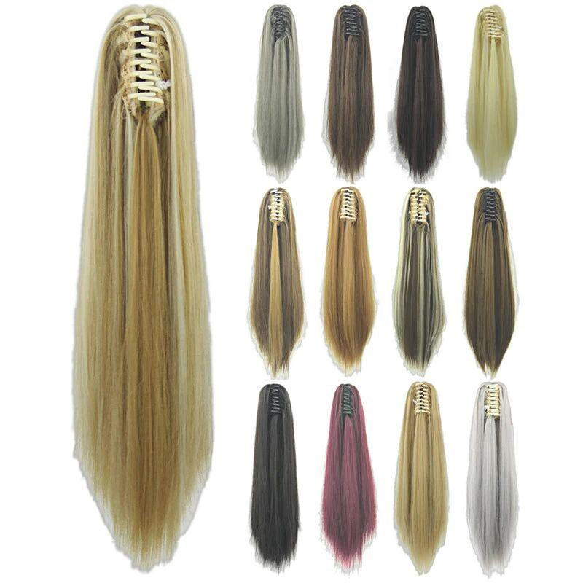 | Straight claw clip in ponytail | 22'', 140g/pc | #1B/27 | $2.96/pc
77 | 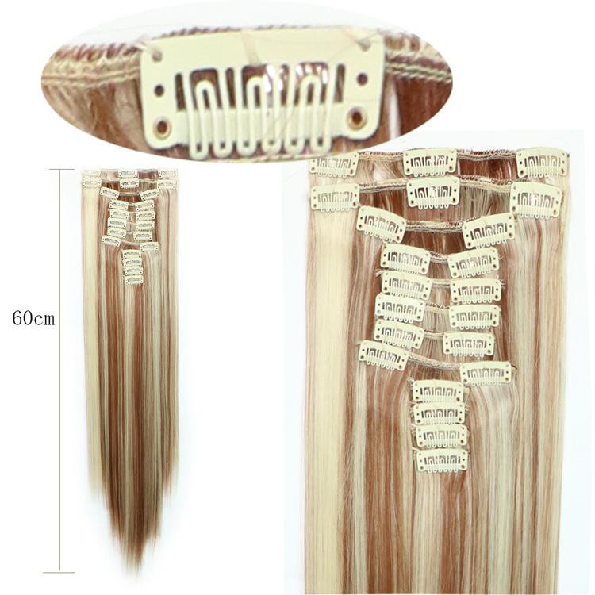 | 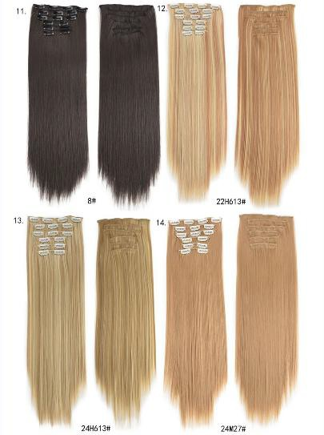 | Straight Clip in ponytail set(6pcs) | 24''.,140g/pc | #1B | $3.26/set
78 |  | 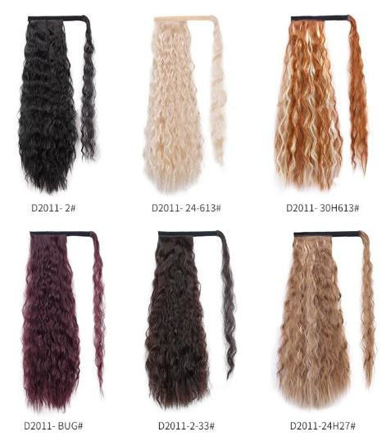 | Wrap around kinky straight corn wave clip in ponytail | 24''.,140g/pc | #1B | $2.96/pc
79 | 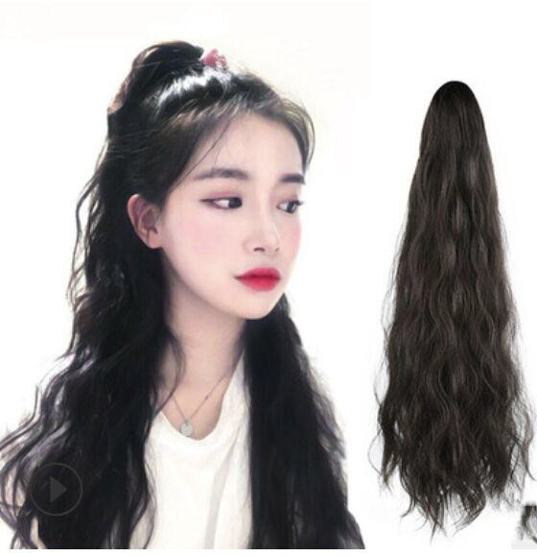 | 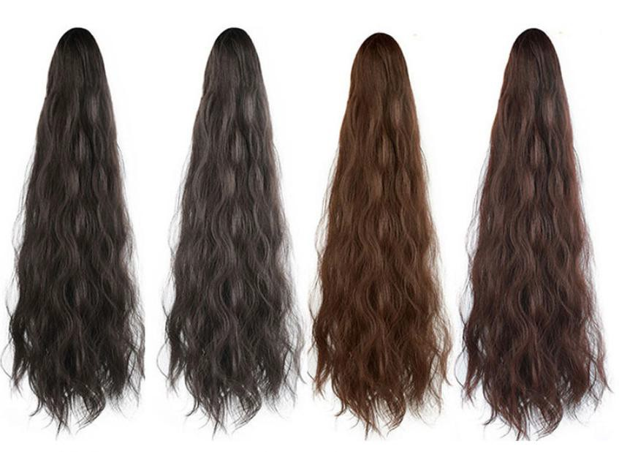 | kinky straight  corn wave Claw ponytail | 22'', 140g/pc | #1B | $2.96/pc
80 | 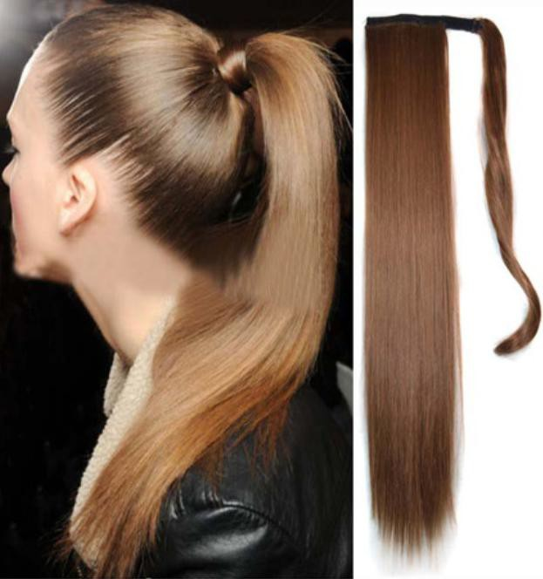 |  | Wrap around straight ponytail | 22‘’，105g/pc | #1B | $2.96/pc
81 | 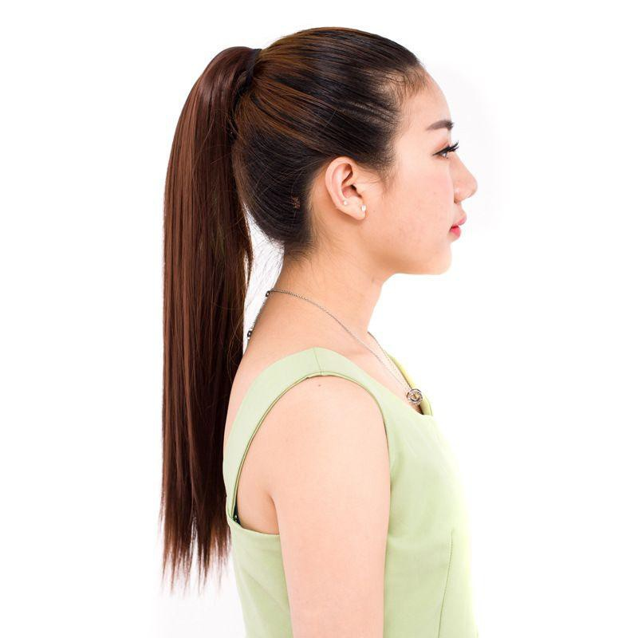 | 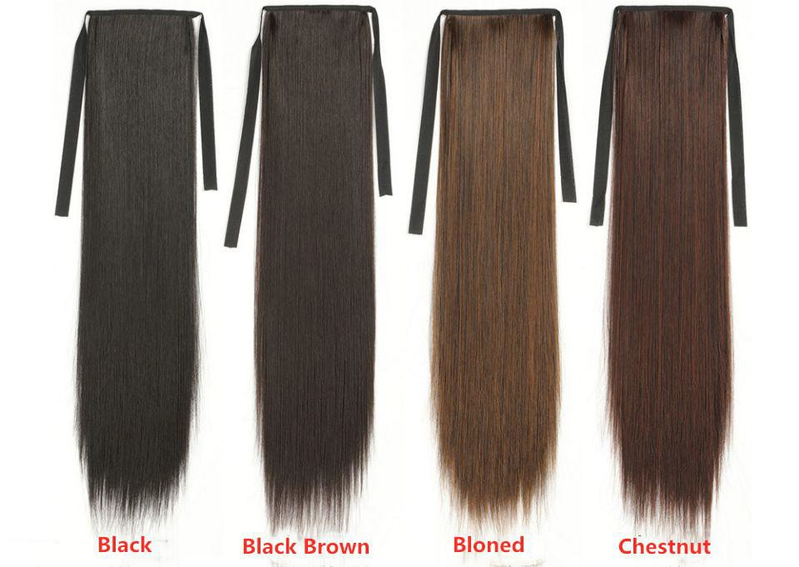 | Headband straight ponytail | 18'',90g/pc  22'' 95g/pc  26'' 105g/pc  30'' 110g/pc | #1B | 18", $2.71/pc  22'',$2.79/pc  26'',$2.83/pc  30", $2.89/pc
82 |  |  | Afro kinky curly drawstring ponytail | 8'',60g/pc | #1B | $3.26pc
83 |  | 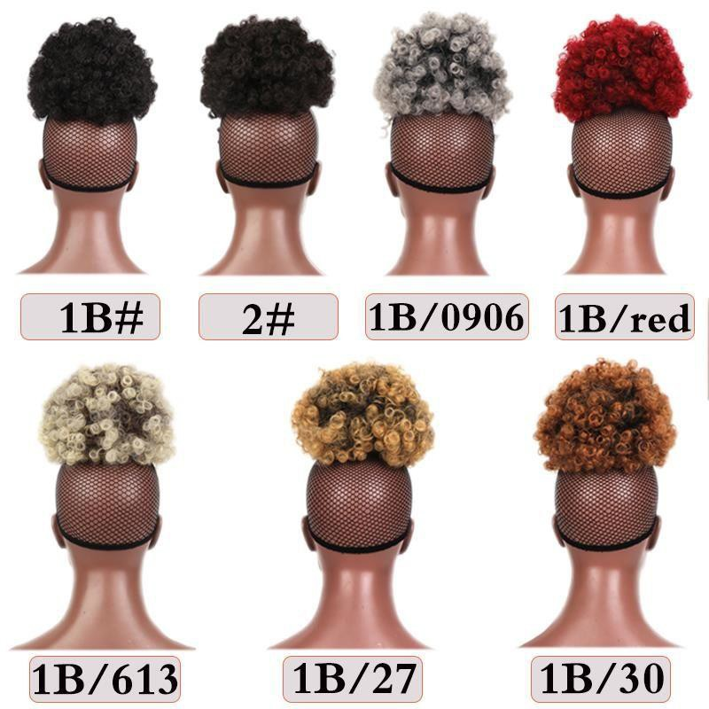 | Afro kinky curly drawstring ponytail | 11*15cm,110g/pc | #1B | $3.56/pc

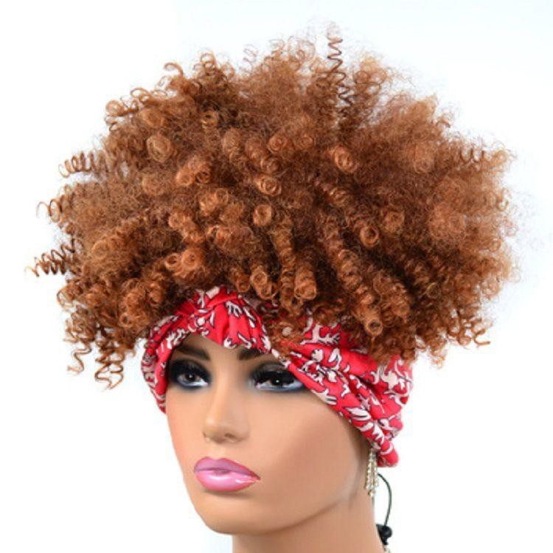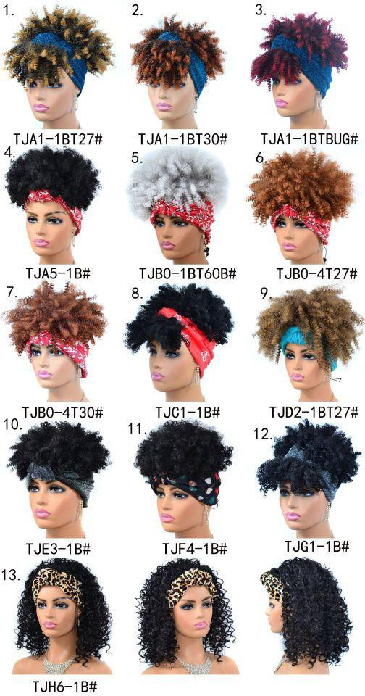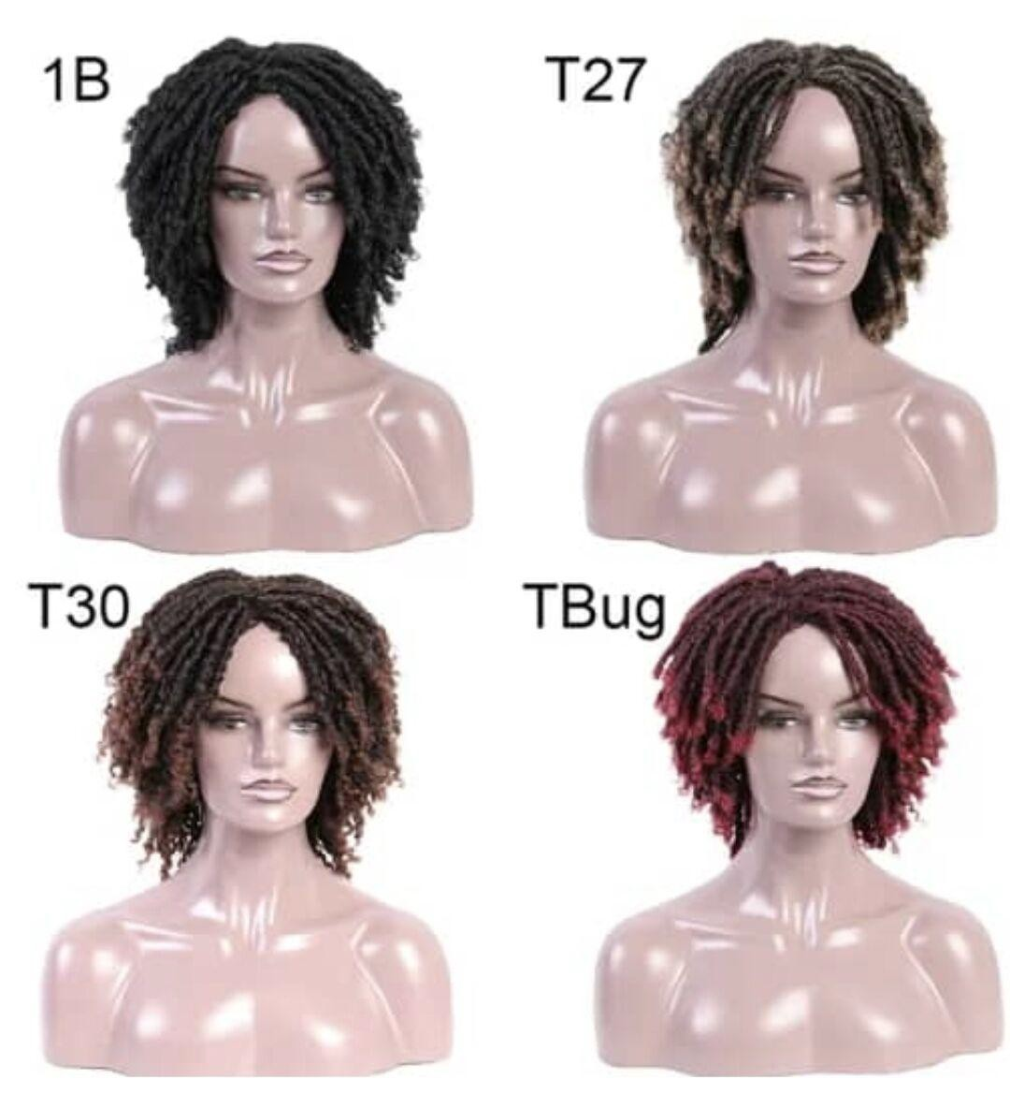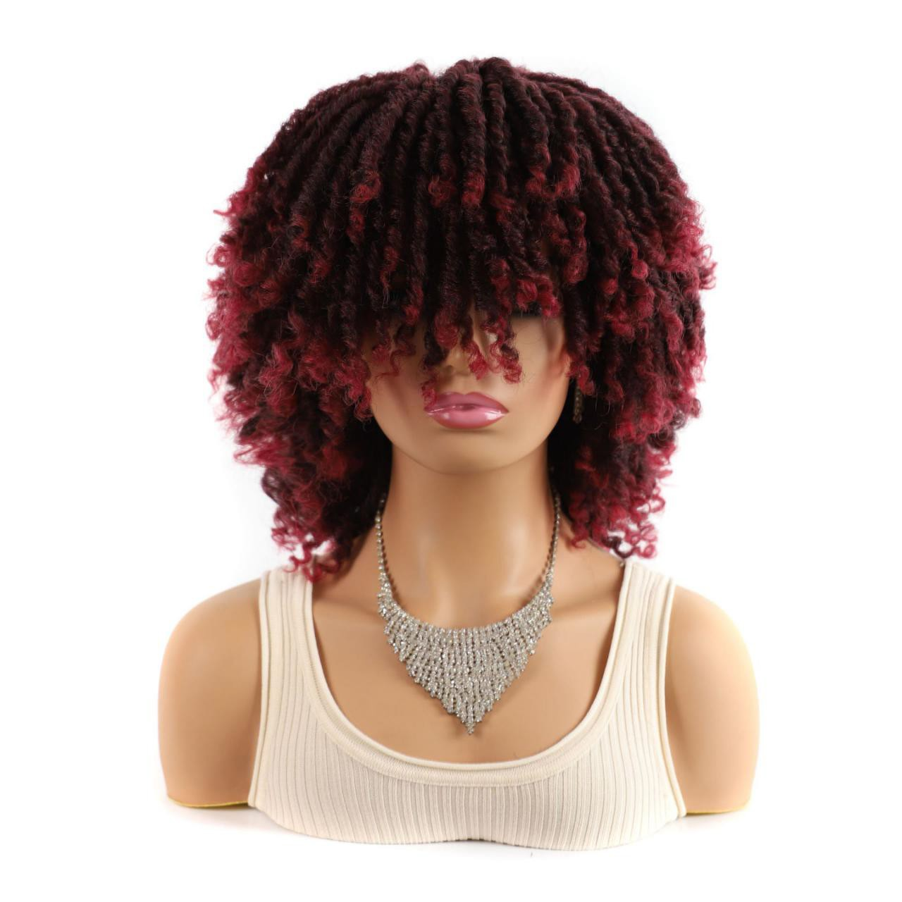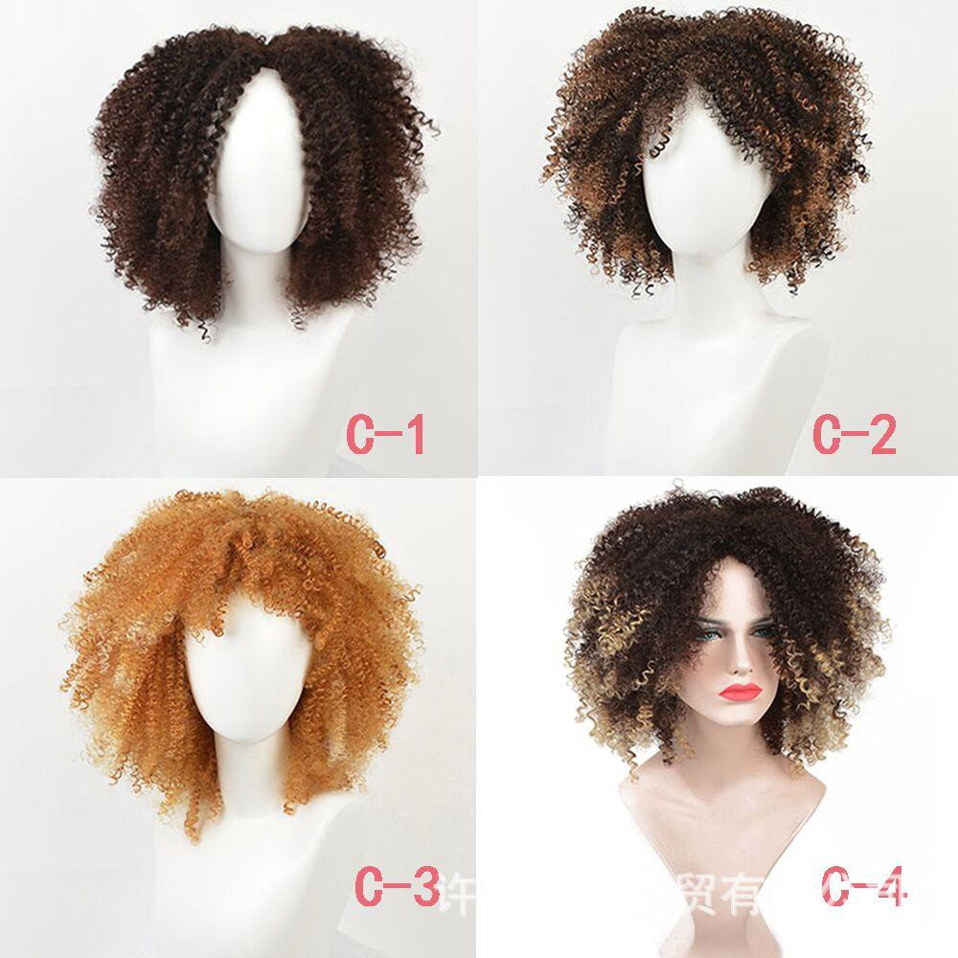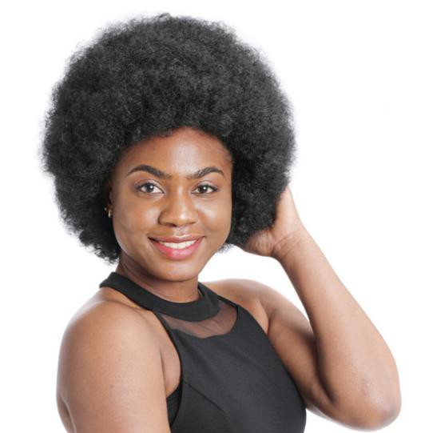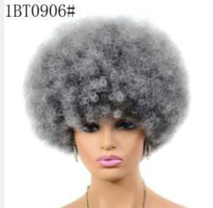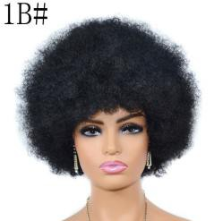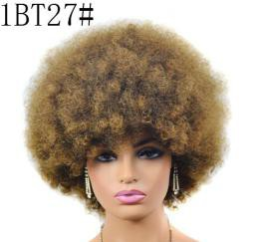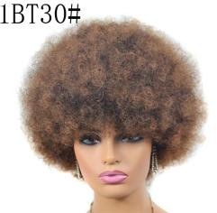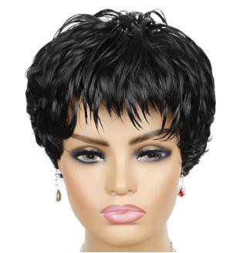
84 | 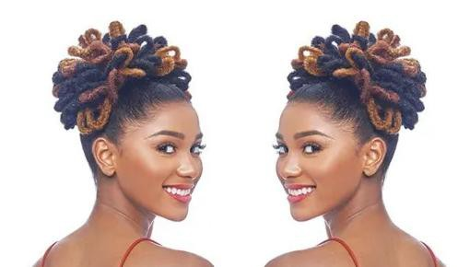 | 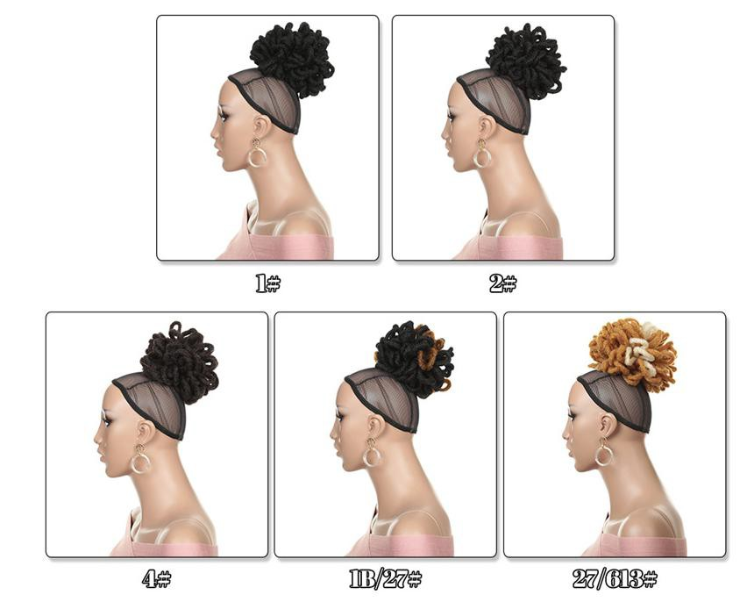 | Afro dreadlocs braiding drawstring ponytail | 4'',110g/pc | #1B | $4.68/pc
85 |  |  | Kinky curly wig with headband | 5‘’, 150g/pc | #1B | $9.66/pc
86 |  |  | Dreadlocs braiding wig | 14'',190g/pc | #1B | $13.45/pc
87 | 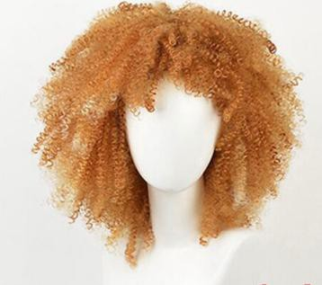 |  | Afro kinky curly wig | 14'',150g/pc | #C-1 | $11.26/pc
88 |  |  | Synthetic Kinky curly wig | 5'',160g/pc | #1BT27 | $9.66/pc
89 |  | 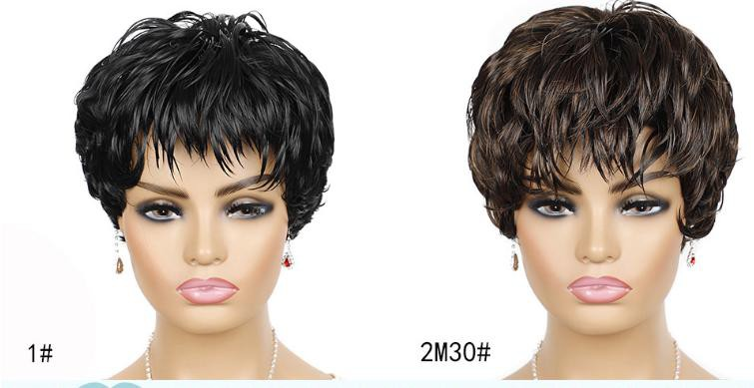 | Synthetic short wig | 5'',130g/pc | #1 | $9.51/pc
90 | 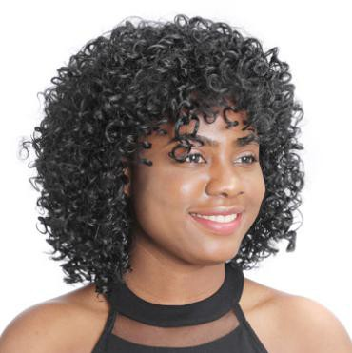 | 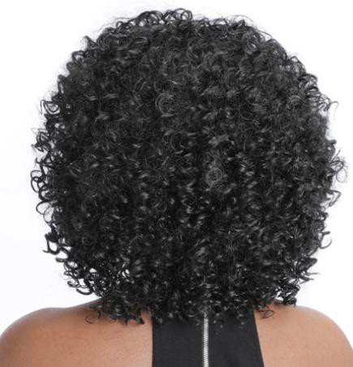 | Synthetic Kinky curly wig  Synthetic Kinky curly wig | 15'',210g/pc | #Black | $9.81/pc
91 | 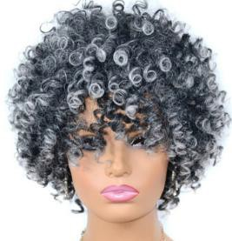 | 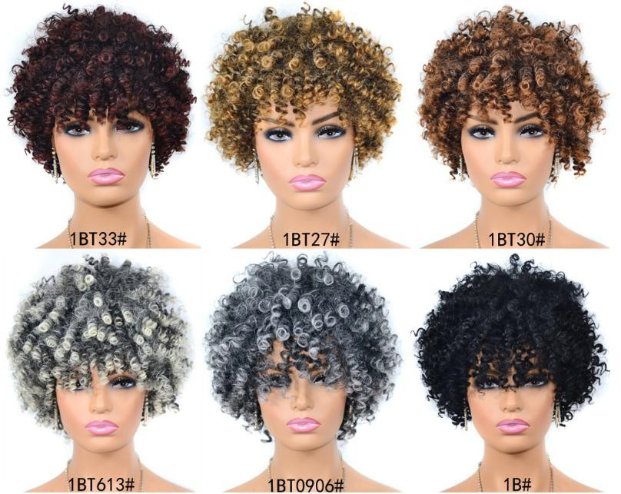 | Synthetic Kinky curly wig  Synthetic Kinky curly wig | 8'',230g/pc | #1BT27 | $10.59/pc

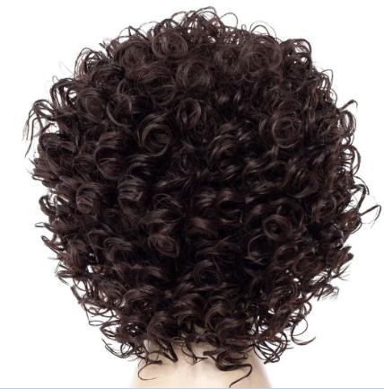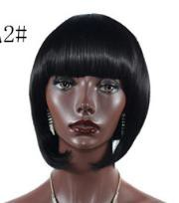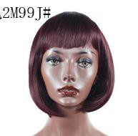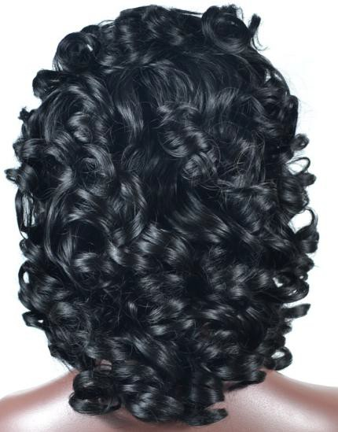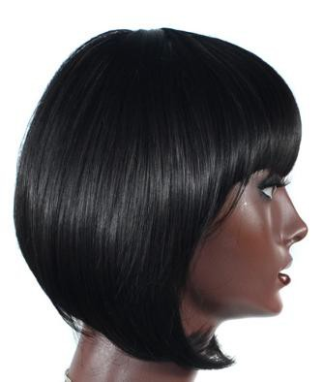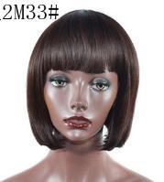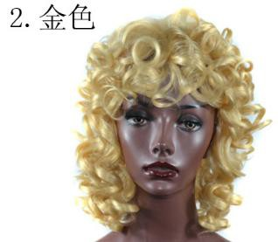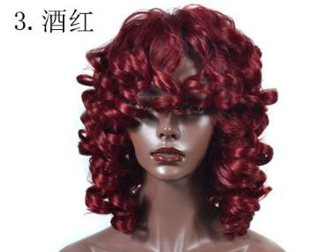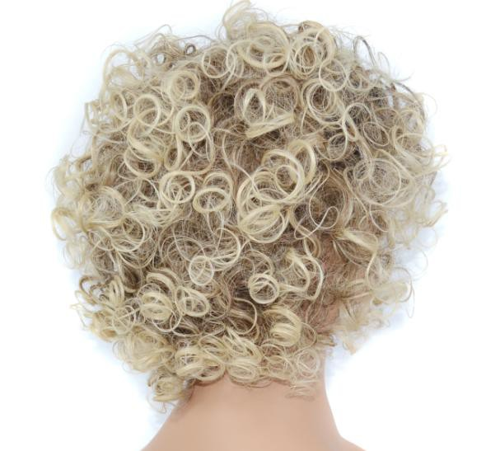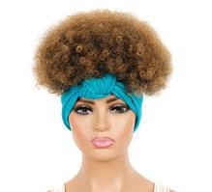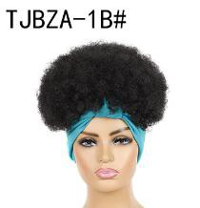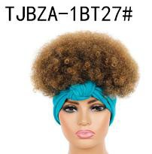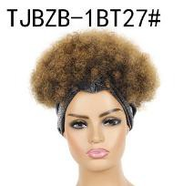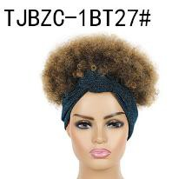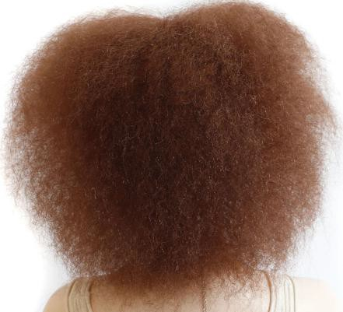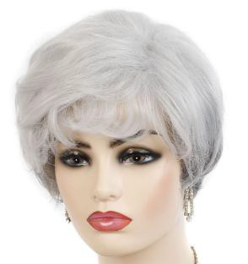
92 | 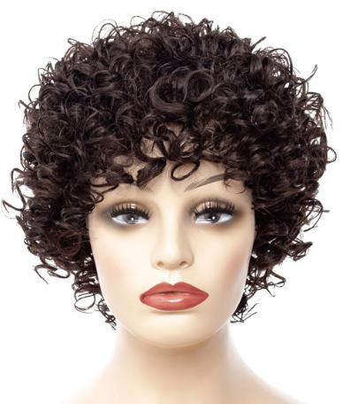 |  | Synthetic kinky curly wig | 14'',200g/pc | #Light brown | $9.59/pc
93 | 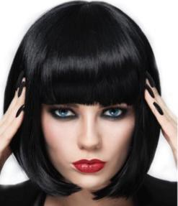 |  | Synthetic Bob wig | 10'',150g/pc | $Black | $9.65/pc
94 | 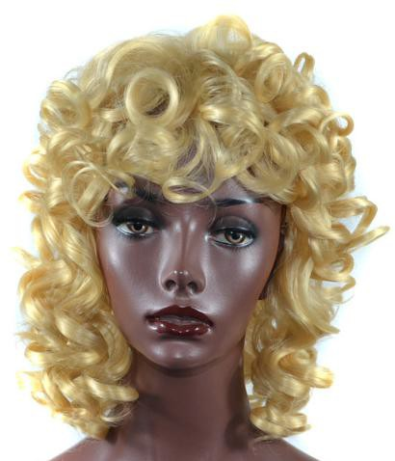 | 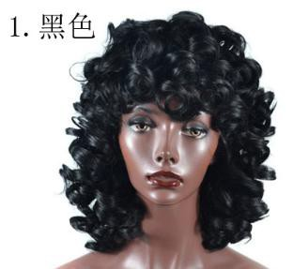 | Synthetic Curly wig | 14'',260g/pc | #27 | $9.65/pc
95 | 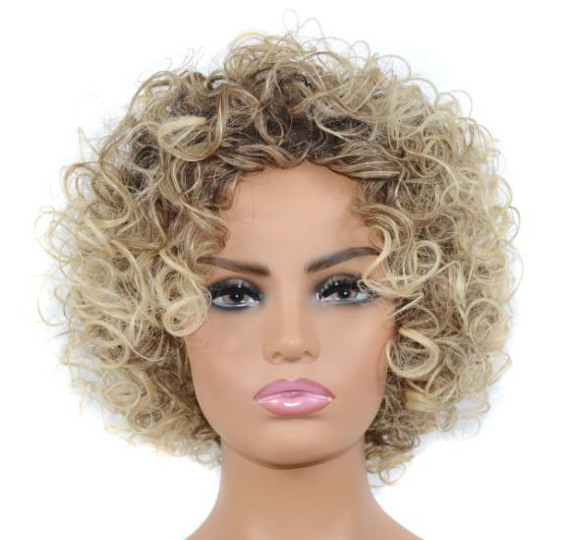 |  | Synthetic curly wig | 12'',180g/pc | #613 | $9.65/pc
96 |  |  | Kinky curly wig with headband | 8'',110g/pc | #1B | $9.65/pc
97 | 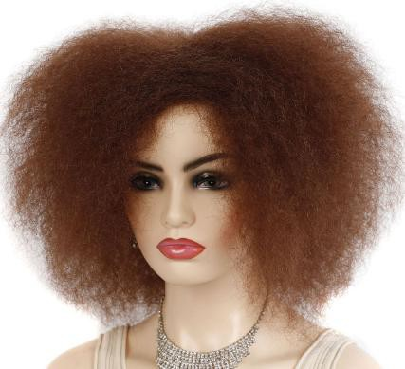 |  | Afro Kinky curly wig | 12'',110g/pc | #Brwon | $10.59/pc
98 |  | 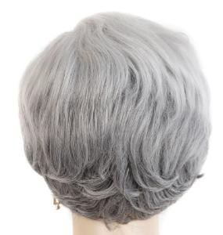 | Synthetic Natural wig | 6'',150g/pc | #Silver grey | $9.56/pc
99 | 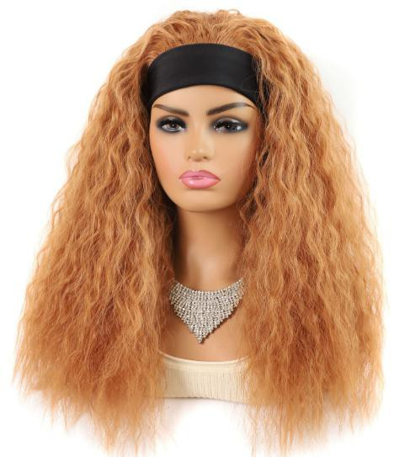 | 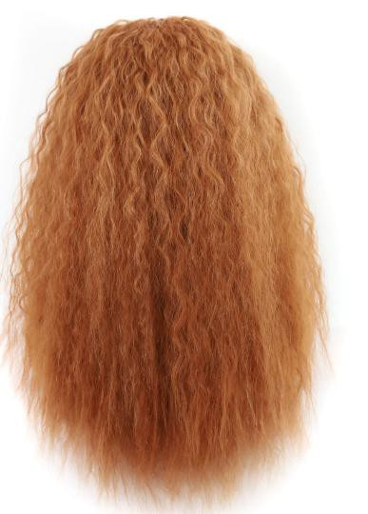 | Afro kinky curly wig with headband | 18'',210g/pc | $Brown | $10.59/pc

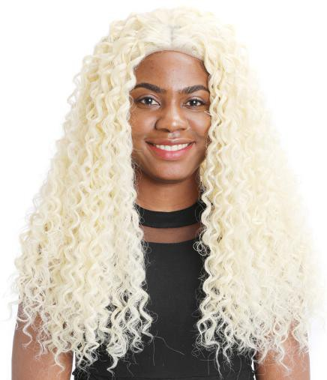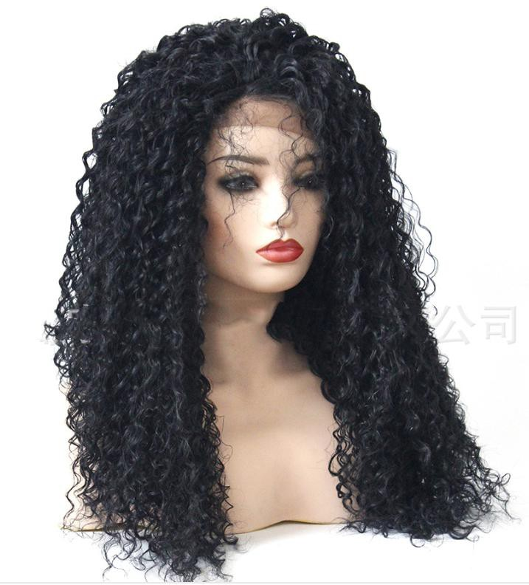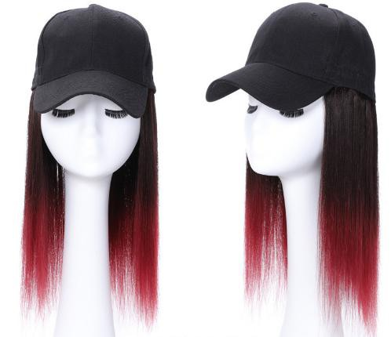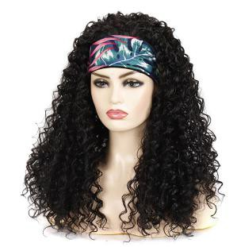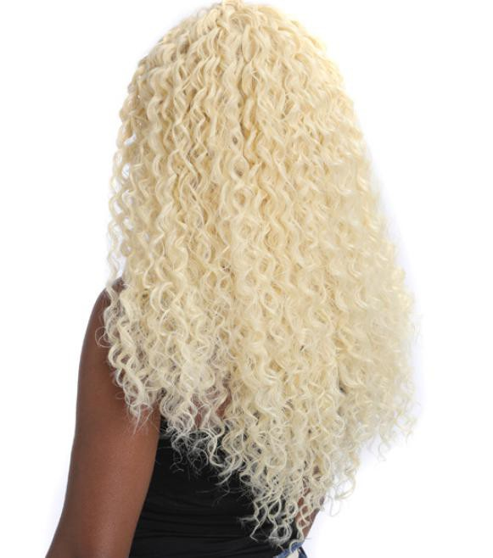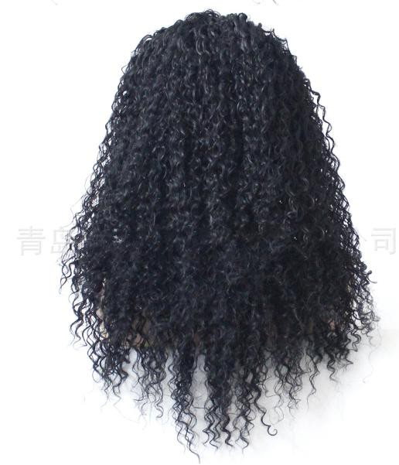
100 |  | 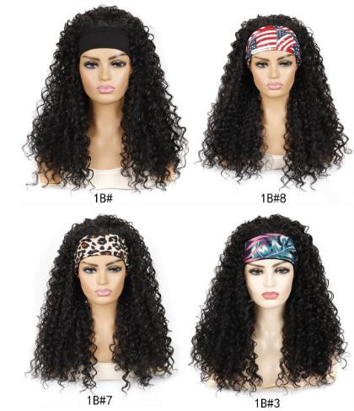 | Kinky curly wig with headband | 12'',250g/pc | #Black | $11.59/pc
101 |  | 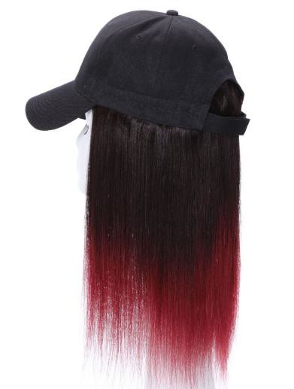 | Synthetic wigs with baseball hat | 16'',230g/pc | #1B/Red | $19.25/pc
102 | 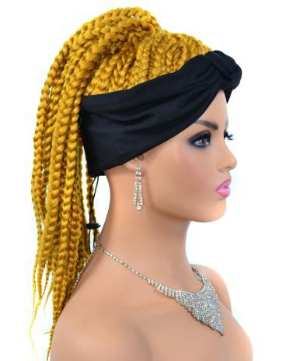 | 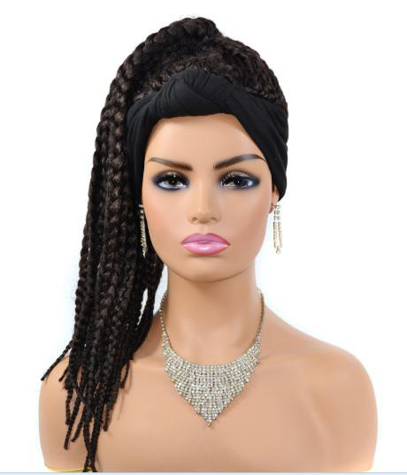 | Box braiding wig with headband  Box braiding wig with headband | 18'',280g/pc | #1B | $29.78/pc
103 | 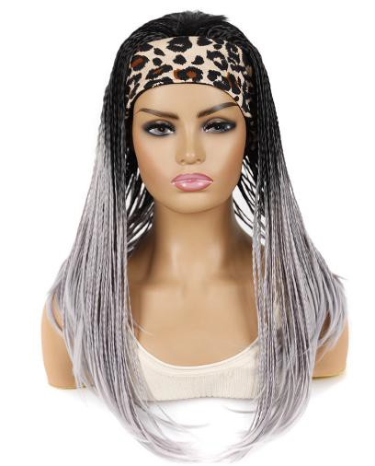 | 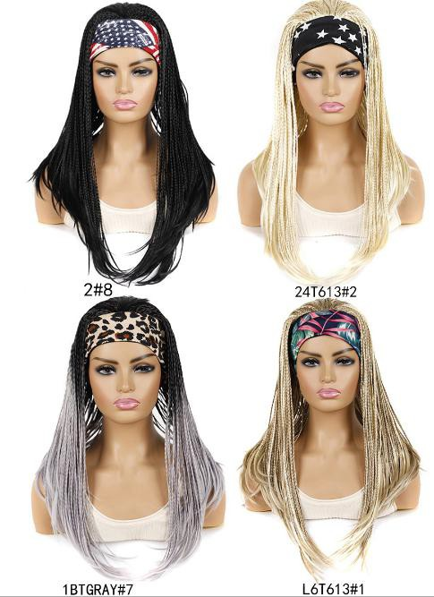 |  | 18'',300g/pc | 2#8 | $32.36/pc
104 |  |  | Synthetic kinky curly wig machine made | 24',340g/pc | #613 | $29.96/pc
105 |  |  | Synthetic 13*3.5 Lace Frontal wig | 14‘’-26‘’，220g-360g/pc | #1B | $32.89/pc
106 | 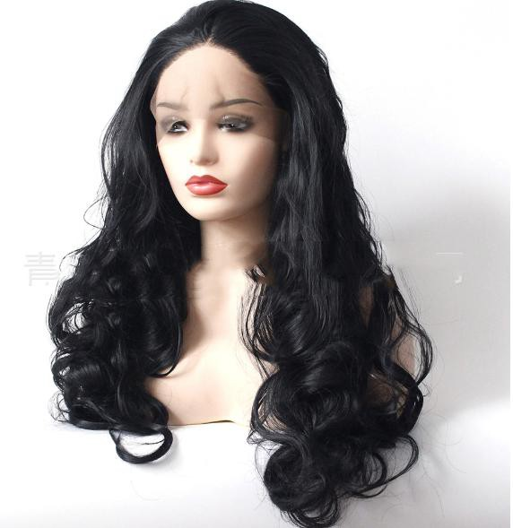 | 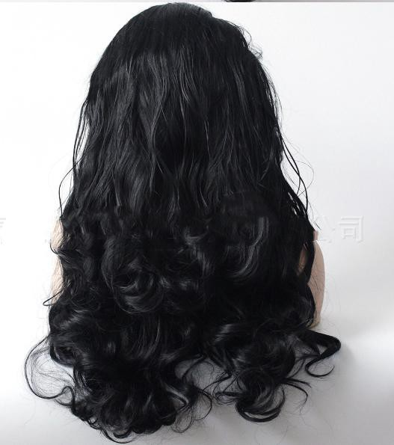 | Synthetic 13*3.5 Lace Frontal wig | 14‘’-26‘’，220g-360g/pc | #1B | $32.89/pc
107 | 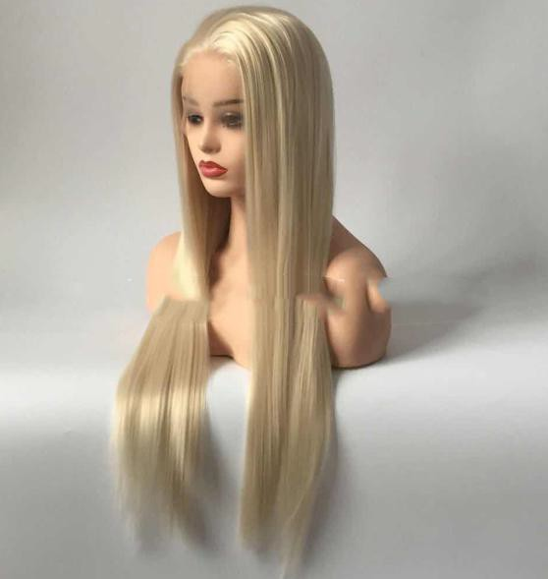 | 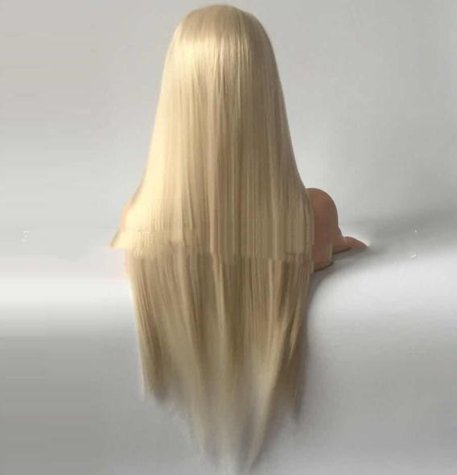 | Synthetic 13*3.5 Lace Frontal wig | 14‘’-26‘’，220g-360g/pc | #613 | $32.89/pc

108 | 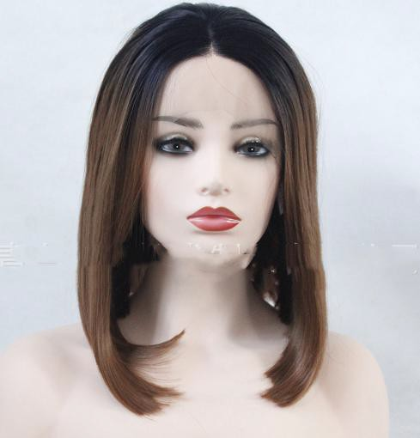 | 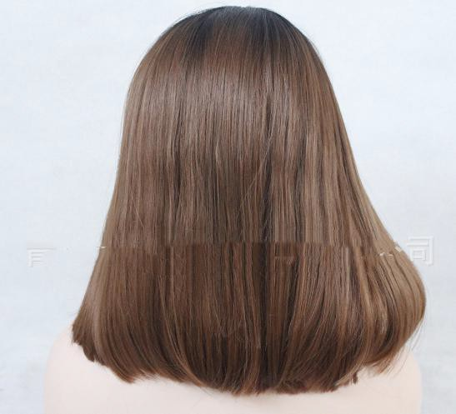 | Synthetic 13*3.5 Lace Frontal wig | 14‘’-26‘’，220g-360g/pc | #1B/30 | $32.89/pc

